

**DTE Process for Team Foundation Server**

**Job Aide**

|  |  |
| --- | --- |
| **Prepared By:** | Chris Dorsch, Matt Cardarella, Steve Zanders, and William Stackpole |
| **Date Prepared:** | 5-14-15 |
| **Date Last Updated:** |  |
| **Version:** | 1.0 |

**Table of Contents**

Introduction 3

How to Install TFS 4

Launching Team Explorer 6

Selecting a Team Project 7

Templates 10

Queries 11

Team Queries 12

Web Portal and Dashboard 13

Create New 15

Work Items 17

How to Create Work Items 18

Saving the Work Item 26

Creating New Linked Work Items for an Epic 27

Work Item IDs 37

How to Create a Bug (work item, that is) 38

Send to Outlook 44

Reference 45

# Introduction

TFS *(Team Foundation Server)* is a Microsoft application to assist in software development. You may also hear TFS called by other names like *Team Explorer and IDE.* It’s all part of Visual Studio’s suite of tools that we can use during the development lifecycle.

TFS is an integrated end to end solution which manages:

|  |  |
| --- | --- |
| * A product backlog *(managed list of business/IT needs)* * Epics * User Stories * Tasks * Defects * Test cases * Iteration status (burn down) * Workflow * Ad-hoc and canned reporting |  |

# How to Install TFS

To access the Team Foundation Server environment, you’ll need to install TFS on your PC. The link to download Team Explorer 2013 is shown below. Follow the directions on the screen to complete the installation.

<http://www.microsoft.com/en-us/download/details.aspx?id=40776>

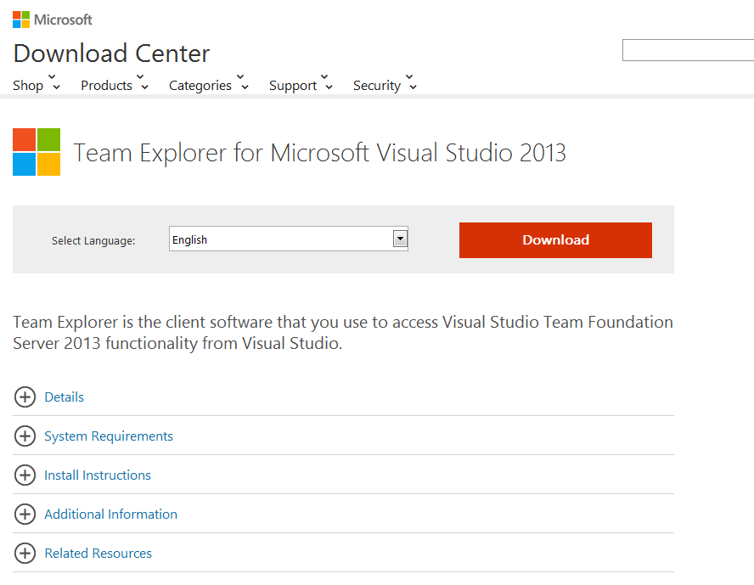

Once you click the Download button, you’ll want to select the first checkbox - the **exe** and **not the ISO** and run it.

Once the exe runs, select the first checkbox for accepting the terms of use & deselect the second checkbox labeled **‘Join the experience program’**.

If at any point the installation asks you to create a Microsoft account select ‘**Not Now – Later’**.

During the install process, the program will caution you about compatibility. This is because Team Explorer uses Internet Explorer as its default browser. If you currently have IE8 installed and set as your default browser, then you’ll want to use a different browser (for instance Chrome) to access the web portal. IE8 works, but not all of the features of TFS are supported in IE8.

Once the installation is complete, you should be able to open TFS which will be located under Visual Studio 2013 in the Windows **Start** menu.

# Launching Team Explorer

You’ll launch TFS from the Start menu – it’s under Microsoft Visual Studio 2013:



**Hint: You can pin the program to your task bar for easy access.**

You may see a message the first time you select a team project. It says ‘You must configure your workspace mappings to open solutions for this project.’ Just click the ‘x’ for this.  Configuring the workspace isn’t needed for managing work items and has to do more with development activities. **(If you do click it, then expect the mapping process to take approximately 30 minutes to map all of the network drives.)**

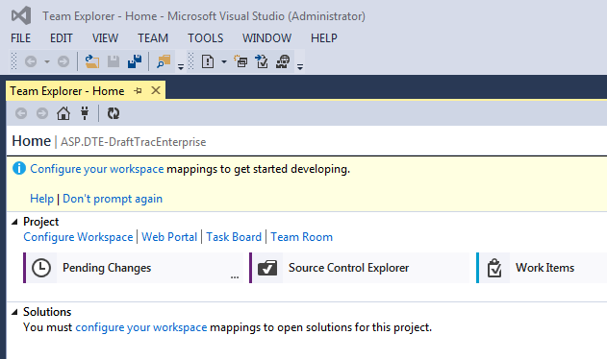

Note: This is the **IDE** view of TFS. IDE stands for **Integrated** **Development** **Environment**. It’s also called **Team** **Explorer**. We’ll use Team Explorer as a reference to this facility in the rest of this document.

# Selecting a Team Project

Your default project is **ASP.DTE-DraftTracEnterprise**. If you want to open a different project, click the down arrow at the far right of the screen on the row Labeled **Home**.

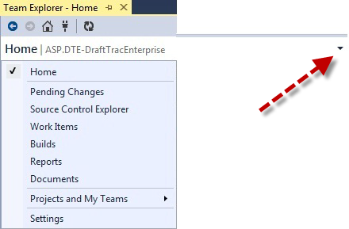

Select **Projects and My Teams,** then **Connect to Team Projects…**

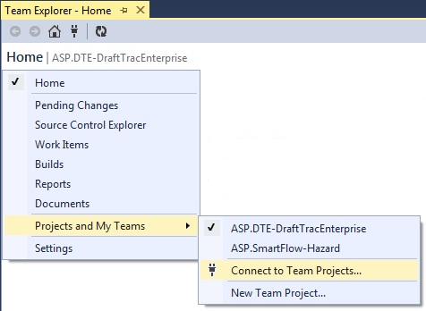

**Hint: You can also click on the little plug icon in the toolbar to access this function.**



The Connect screen will appear. Click on **Select Team Projects…**

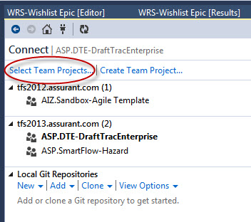

Note: On this screen you’ll see the projects that you currently have pinned to your Team Explorer workspace. The one that has focus is shown in **Bold**.

Note: Depending upon your security access level, you may or may not be able to use the **Create Team Project** feature.

Put a checkmark in the box next to the project(s) you want to use.

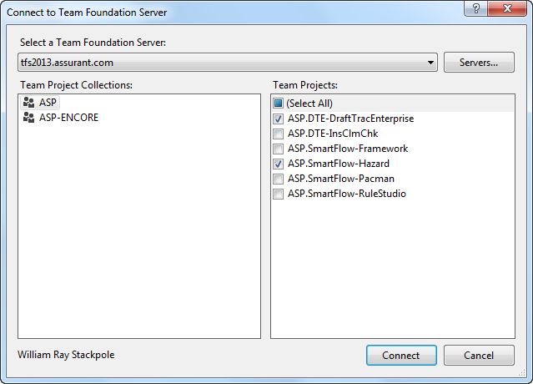

Let’s choose **ASP.DTE-InsClmChk.** Click **Connect** to add this project to our list.

Now, it’s in our list of projects, and it has focus. A project with focus in Team Explorer is the one that provides you with a specific project template. We’ll see how templates work in the next section.

|  |  |
| --- | --- |
|  | To remove a project from the list, click **Select Team Projects** and uncheck the box next to that project.  Click the **Home** icon (the little house icon in the toolbar) to return to the main menu. |

# Templates

Each project can have its own template. A template is a project design configuration that provides the user with a specific set of work items and features. This makes sure that only the appropriate work items are entered on this project. For example, here are two projects each with a specific template:

|  |  |
| --- | --- |
| **SmartFlow Template** | **DTE Template** |
|  |  |

# Queries

Team Explorer provides a robust query facility that allows the user to access work items in their projects. This job aide does not spend a lot of time on how to use queries. For quick reference, there is a document entitled **How to work with Queries** located in the Reference section of this document.

To get to the query functions, click on the **Home** icon to return to the main Home menu. Then, click on **Work Items** on the menu bar.



This brings up the Work Items functions menu.

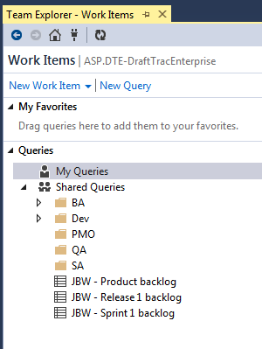

**My** **Favorites** – frequently used queries that show record counts without having to run them.

**My** **Queries** – Queries that you have created – only you can see them.

**Shared** **Queries** – Queries that are used by the team. These are broken down by role. Anyone can run these.

## Team Queries

Management has designed a set of queries that will help the team search out work items for their projects. You can find these under **Sharded Queries** in the **PMO** folder. These are often referred to as Team Favorites and are queries that are frequently used by the team.

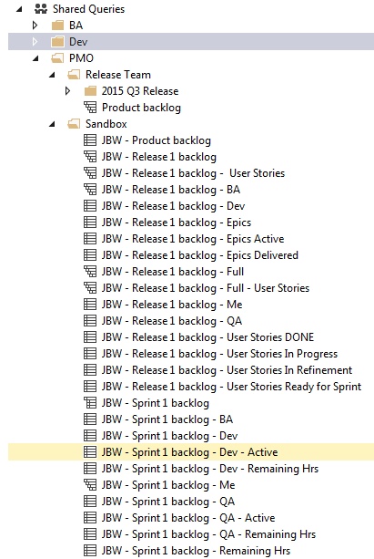

# Web Portal and Dashboard

The web portal (officially known as **Team** **Web** **Access** or **TWA**) is really a team dashboard. It’s an easy way for management and team members to get the “Big Picture” about what’s going on with the project.

You can get to the web portal from Team Explorer by clicking the **Web Portal** link:

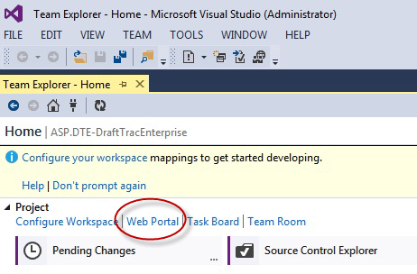

**Caution: Internet Explorer 8 is not supported by Visual Studio 2013. Some of the fucntions will work, but not all. It’s best to launch the web portal from a supported bowser like Chrome.**

To get to the web portal without these problems, open up your Chrome browser and use the following URL:

<http://tfs2013.assurant.com:8080/tfs/ASP/ASP.DTE-DraftTracEnterprise>

**TFS Dashboard**

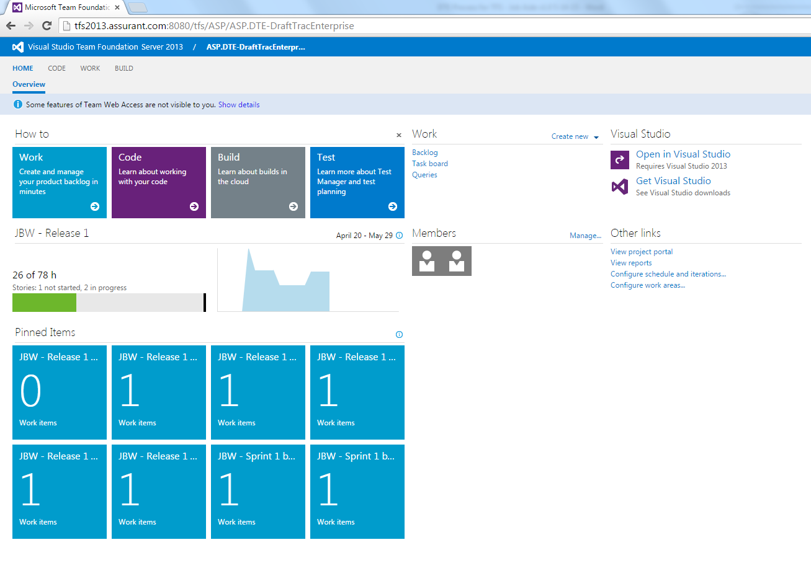

**NOTE: Management is still deciding on the best components that they want to show on this page to help the teams. It’s likely that all teams will have the same dashboard configuration initially, then management will how each team evolves to use different data in their processes.**

Typical features of this dashboard are the How Tos shown at the top of the screen, bar and pie charts of the team Burndown in the middle, and blocked labeled Pinned Items which are in fact the results from the team queries.

You can switch to another project area by clicking on the current project name to get the others that are in your project list.

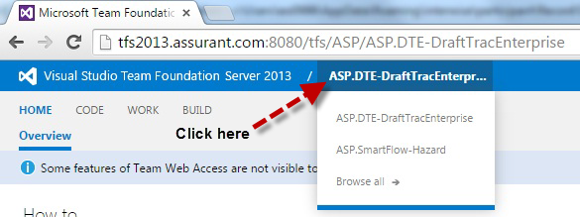

## Create New

You can create new work items from this page. The dialog boxes look different than Team Explorer, but the results are the same.

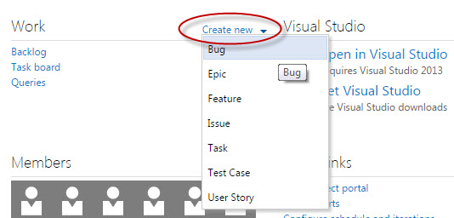

You’ll probably work in the Team Explorer screens when creating or managing work items. For quick access to TFS, pin the application to your task bar in Windows.



On the main tab menu at the top, you have **Home**, then **Code** (not covered here), and then **Work**, which shows you the user stories that have been added and not worked, and those that are in-progress.

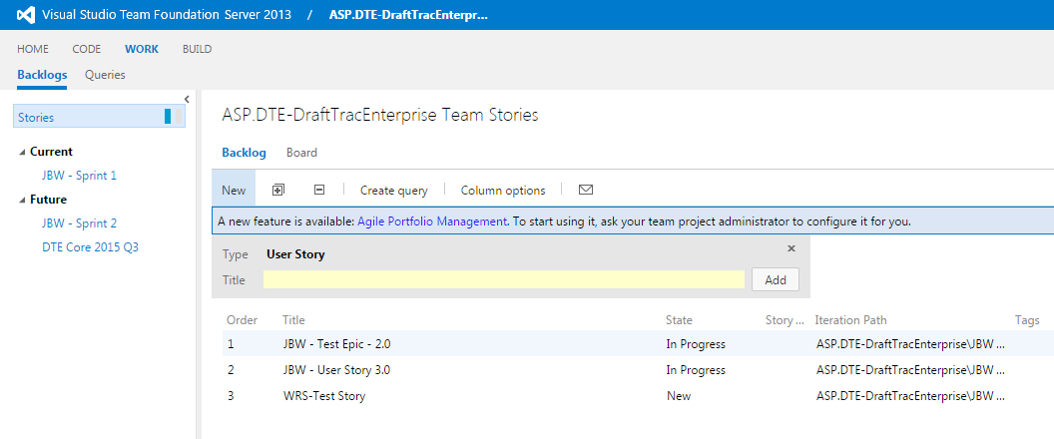

In this view, you can change the order of the stories simply by moving the entry up and down the list. – **Caution: All TFS activities are logged, so they will know which user did this.**

# Work Items

A Work Item is a generic term used in TFS to denote either a placeholder or a specific activity. Team Explorer makes it easy to create, modify, and locate work items.

Work item types that you’ll use are:

* **Bug** – used to document/report problems within the software.
* **Task** – specific, measureable elements that are tracked. There are one or many tasks under a user story and they represent the work needed to complete the user story.
* **User Story** – A story is an individual feature or requirement that the business wants. It is something that is deliverable (i.e. production ready) within a single sprint. The elements of a story. Stepping stones to take the story to ‘Done’. Tasks often follow the SMART acronym: specific, measurable, achievable, relevant, time-boxed (although what the letters stand for seems to be hotly debated).
* **Epic** –An epic is a big story. A requirement that is just too big to deliver in a single sprint. Epics need to be broken into smaller deliverables (stories). This helps them support [the agile principles](http://agilemanifesto.org/principles.html) (e.g. delivering working software frequently, early continuous delivery, regular reflection).
* **Feature –** (Not currently used)
* **Issue -** (Not currently used)
* **Test Case** – the specific testing QA will perform. There are one or many test cases for each user story to test the user story’s acceptance criteria.

## How to Create Work Items

**Follow the steps below and on the next few pages to create an Epic work item in TFS. This tutorial walks you through creating the Epic, it’s linked User Stories, and the Tasks linked to each User Story.**

In Team Explorer, click on the **Work Items** tab on the Home page.

Click on **New Work Item.**

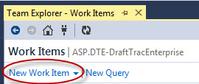

You’ll see the list of work item types available in this project template.

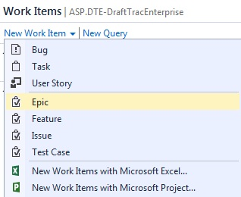

Choose **Epic**

Before we fill in the details about this epic, let’s take a look at the naming convention for this type of work item. The **Title** of the Epic should be in the following format:

**PPM ppm number – brief description**

Example: PPM 310316 – Client Specific Setup

Now, name the work item using the standard naming convention in the space with the **<Enter title here>** prompt.

Next, fill in the details for this work item under **Details**.

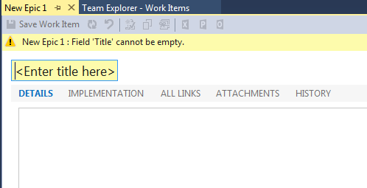

Click on I**MPLEMENTATION**

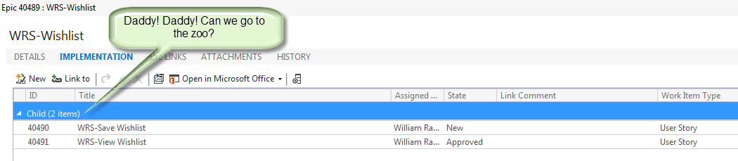

This form lists all the children (user stories) that are linked to this epic. (We’ll come back to this function when we create the User Stories for this Epic.)

Click on **ALL LINKS**

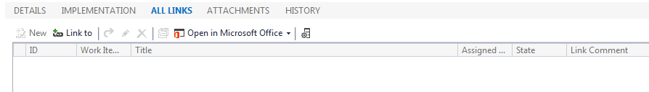

This form shows the parents (epics), their children (user stories), and other related work items for this epic.

Click on **ATTACHMENTS**

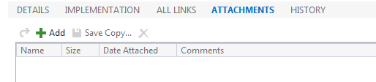

This form shows you any attachments associated with this work item. For an explanation of how to add an Attachment, see the ‘**How To Add Attachments to a Work Item**‘ procedure located in the Reference section at the end of this job aide.

Click on **HISTORY**

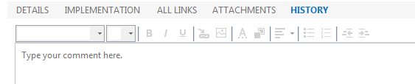

This feature shows you the log for this work item that contains every activity posted against it. For an explanation of how to work with the History log, see the ‘**How To Work with History**‘ procedure located in the Reference section at the end of this job aide.

To the right of the Details entry space, you’ll see additional fields for this work item. There are three sections: Status, Planning, and Classification. Not all of these are used for DTE epics. On the next few pages we’ll show what to fill out in each of these fields.

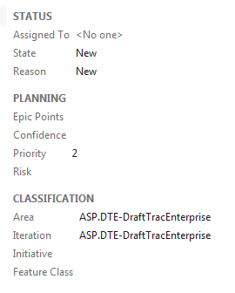

**STATUS**

**Assigned To**

This field lets you assign the Epic to a user. Mouse over the text <No one> to the right of the Assigned To prompt and you’ll see a dropdown arrow. Click the arrow to get a list of all available TFS users on this project appears.

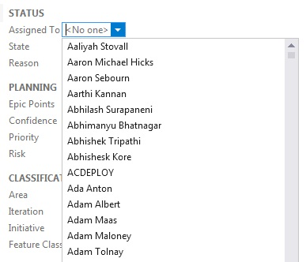

You can scroll through the list and pick a name. The names are in alphabetical order by First and Last name. Once you select a name it will appear in the Assigned To entry field.

Another way to enter the name is to click on the <No one> box and start typing the name. TFS will find the closest name to the letter you type.

**State**

State represents the status of this work item. All new work items are marked **New**.

For Epics, there are two scenarios where the state change from one status to another varies. These are for **Product** releases and **Backlog** releases.

In a Product release, the work item state goes from **New** to **Active** when the business analyst begins to gather information for the Scope Analysis document. The state remains in Active status until the item is **Removed**, or it is approved.

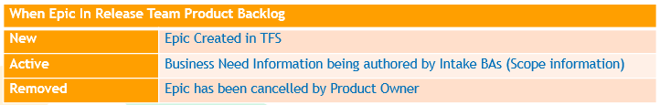

If the Epic transitions into a backlog item (it’s approved to move forward as a project), then the **Active** state remains while business requirements are gathered. User stories are created during this state.

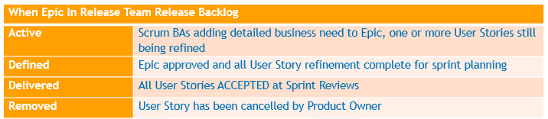

Once the Epic is approved (business requirements have been completed and approved, and the user stories are done), then we’ll see the state move to **Defined**.

The epic moves to a **Delivered** state after all the user stories have been accepted.

The graphic on the next page represents the state changes for an Epic work item type.

**EPIC State Changes in the TFS process**

|  |
| --- |
|  |

**Reason – Not currently used.**

**PLANNING**

|  |  |
| --- | --- |
| **Epic Points – not currently used** |  |
| **Confidence** – The preset percentages allow you to note the level of confidence the team has in completing this epic. - **not currently used** |  |
| **Priority** – Preset priority choices for ordering the epic within the project. |  |
| **Risk** – Preset risk levels to represent the inherent challenges in completing this epic. |  |

**CLASSIFICATION**

|  |  |
| --- | --- |
| **Area –** defines the team. | **DTE Core Release Team** |
| **Iteration** – defines the release. | **2015 R4 – June** (example) |
| **Initiative – not currently used** |  |
| **Feature Class – not currently used** |  |

## Saving the Work Item

After all the work item information has been entered, you need to **Save** the work item to the TFS database.



## Creating New Linked Work Items for an Epic

As we saw before, the Implementation form lists all the children (user stories) that are linked to an epic. We could use the long method to add User Stories to our Epic (i.e., create the Epic, then create the User Story, then create the Task(s), and after all that is done, link the work items together). Or, we could employee the **New Linked Work Item** feature to create our User Story while we’re still working with the Epic.

First, save the work item. After the save, click on I**MPLEMENTATION.** You’ll see the **New Linked Work Item** command has been enabled.

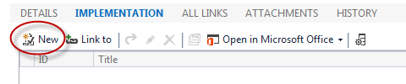

Click on **New** to bring up the work item link screen.

Note: There is also a naming conventions for User Story titles:

The Title of User Stories associated with an Epic should be the following format:

**PPM ppm number - User Story Number Short Description of User Story**

Production Support Requests prioritized into a Release Cycle, will be represented in the Release Backlog as a User Story.  The Title of the User Story should be the following format:

**Prod Support ppm number - PPM Short Description**

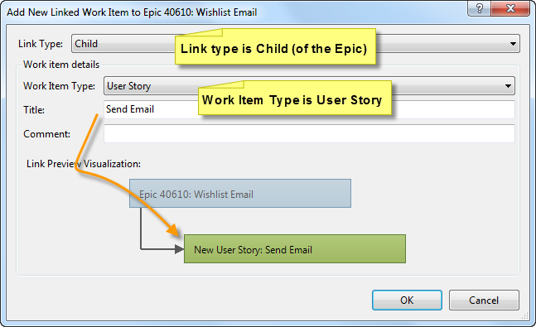

**Link Type** should be **Child** (remember: we are creating a Child work item, a User Story, to our parent work item, an Epic).

Select the **Work Item Type** as **User Story**.

Fill in the **Title** using the naming convention.

**Comment** is optional.

Click **OK**.

The **New User Story** entry screen will appear. Enter your user story description under **Details**. In this section, include the actual user story, acceptance criteria and assumptions, risks, constraints and dependencies.

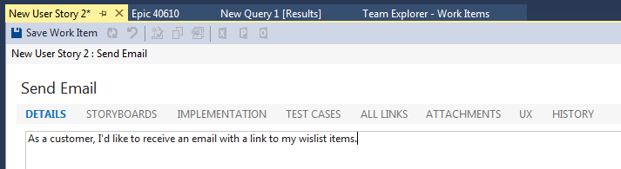

**Save** this work item before moving on to the next step.

**STORYBOARDS – Not currently required.**

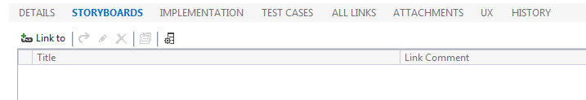

**TEST CASES -** The DTE Team should not be required to create new Test Cases. However, you’ll have an opportunity to view the test cases entered by IT/QA through the web portal.

**ALL LINKS** shows all related work items (parents, children, etc.)

See the Reference section for instructions on how to add attachments and work with History.

Next, we’ll fill in the additional information for this User Story.

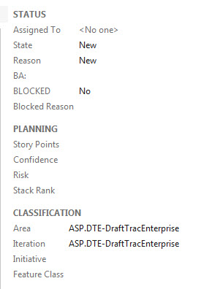

**Status**

Assigned To – use the same method that we did for the Epic work item.

**State**

State represents the status of this work item. All new work items are marked **New**. For User Stories, there are three scenarios where the state change from one status to another varies. These are for **Product** Backlog, **Release** Backlog and Sprint **Backlog**. Below are the State designations for each phase:

|  |  |
| --- | --- |
| **When User Story In Release Team Product Backlog** | |
| **New** | Initial User Story being authored by Intake BAs |

|  |  |
| --- | --- |
| **When User Story In Release Team Release Backlog** | |
| **New** | User Story / Acceptance Criteria being authored by Scrum BAs |
| **Approved** | User Story / Acceptance Criteria ready for Task Refinement and reviewed with business stakeholders |
| **In Analysis** | User Story Task Refinement in progress |
| **Ready** | User Story refined to point that it is ready for sprint planning |
| **Removed** | User Story has been cancelled by Product Owner |

|  |  |
| --- | --- |
| **When in User Story in Release Team Sprint Backlog** | |
| **Committed** | User Story not being worked |
| **In Progress** | User Story actively being worked by IT-DEV or RULES |
| **In Progress** | All  IT-DEV and RULES tasks ready for test, but User Story not being tested |
| **In Progress** | QA test in progress |
| **In Progress** | All QA tests PASSED, but BA review not complete |
| **DONE** | BA reviewed test results and claimed DONE, User Story targeted for sprint review  (In Template – status indicates PO accepted) |
|  | PO and stakeholders accepted DONE status at sprint review  (Not in Template) |
| **Removed** | User Story has been cancelled by Product Owner |

The graphic below represents the state changes for an Epic work item type.

**User Story State Changes in the TFS process**

|  |
| --- |
|  |

**Reason** – read only – reason for the most recent state.

**BA** – SCRUM team BA assigned to this user story.

**Blocked** – Yes/No

**Blocked Reason** - Free form reason for user story being blocked. Example: waiting on dependency, environmental issues, any impediment(s).

**Planning – not used**

Stack Rank – not used

**Classification**

**Area** – designates the SCRUM team name.

**Iteration** – the release or sprint.

**Initiative** – not used

**Feature Class** – not used

**Save** this work item before moving on to the next step.

Next, click **IMPLEMENTATION**. We’re going to add the tasks to this user story.

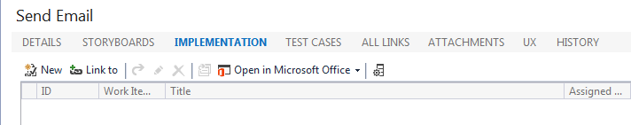

Just like we did for the Epic, we’ll use the New Linked Work Item feature to add our Tasks to this user story. Click **New**.

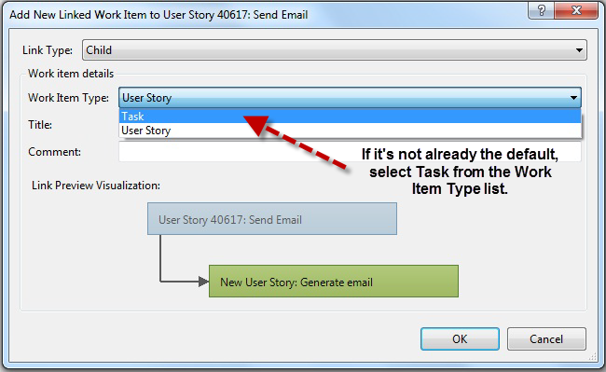

Fill in the **Title** for this task.

Click **OK**.

The New Task entry screen will appear. Enter your task details under **Description**.

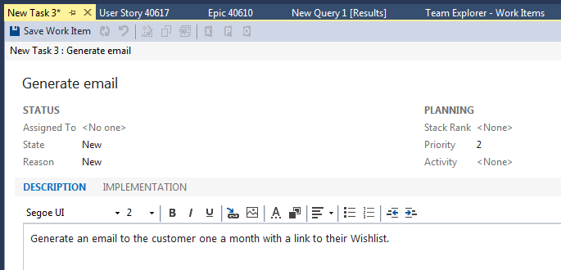

Additional Fields for Tasks:

|  |  |
| --- | --- |
|  |  |
|  | Not used |
|  | Inherited from User story |
|  | Fill in Original Estimate  Remaining – entered by user  Completed – entered by user |

**State**

|  |  |
| --- | --- |
| **When Task In Release Team Release Backlog** | |
| **New** | Task being authored or has been authored by Scrum Team |
| **Removed** | Task has been cancelled by Scrum Team |
| |  |  | | --- | --- | | **When Task In Release Team Sprint Backlog** | | | **New** | Execution of task has not started | | **Active** | Task being executed | | **Closed** | Task execution complete | | **Removed** | Task has been cancelled by Scrum Team | | |

**Task State Changes in the TFS process**

|  |
| --- |
|  |

**Save** the work item.

## Work Item IDs

As the work item is saved, TFS assigns it a unique ID number. This number refers to this work item and is unique across all TFS projects.

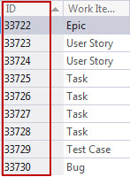

# How to Create a Bug (work item, that is)

**Follow the steps below and on the next few pages to create a Bug work item in TFS.**

In Team Explorer, click on the Work Items tab on the Home page.

Click on **New Work Item.**

Choose **Bug**.

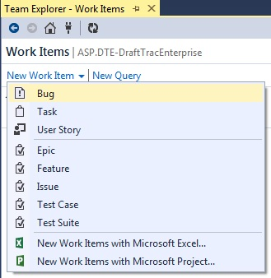

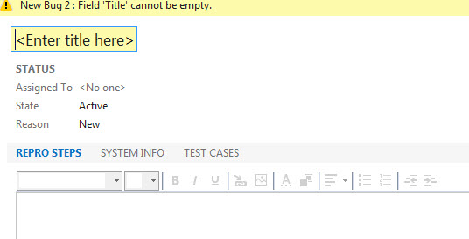

Enter a **Title** for this work item.

Enter the steps to reproduce the bug under **REPRO**.

Next, click **SYSTEM INFO**.

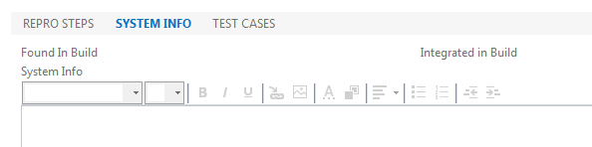

Enter any information like systems variables that would cause the bug. These could include loan#, tracking number, userid, ad other systems variables.

Click on **TEST CASES**.

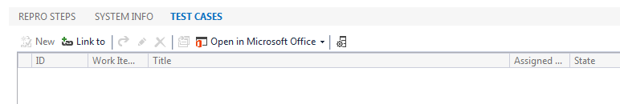

Use the **Link to** feature to locate and associate a test case with this bug. You will get the **Add Link to New Bug** dialog screen as shown on the next page.

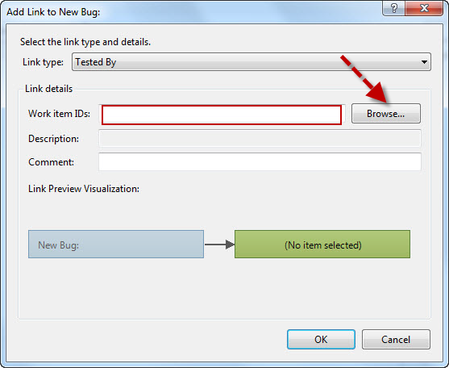

The Link Type will default to Tested By. This shows that this bug is associated with a Test Case.

Under Link details, you can enter in the number of the work item that was assigned to the test case in the entry field labeled Work item ID. There’s several ways to select these:

* Type in the work item ID# for the desired test case in the field. If there is more than one test case to be used, type in the list of work item numbers separated by commas.
* Click on Browse to bring up the

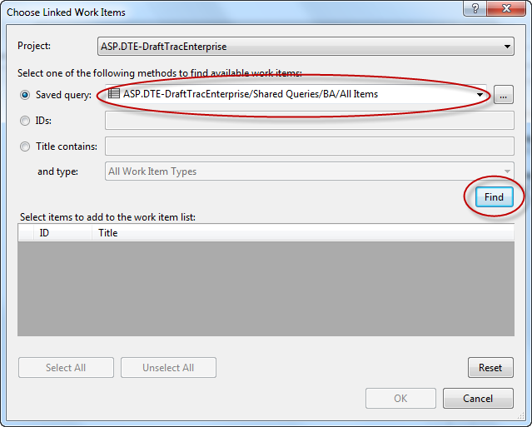

Find a saved query and click Find to run it. The query results will be displayed in the Select items pane as shown below.

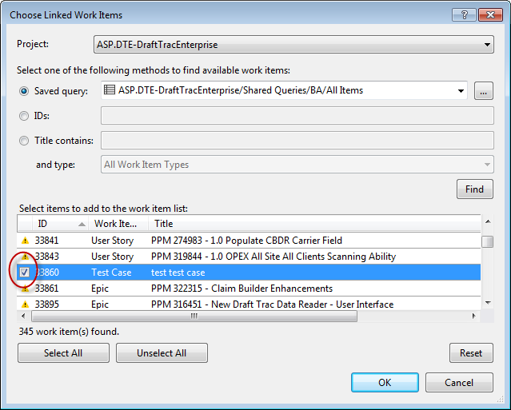

Mark the checkbox next to the test case(s) you want and click **OK**.

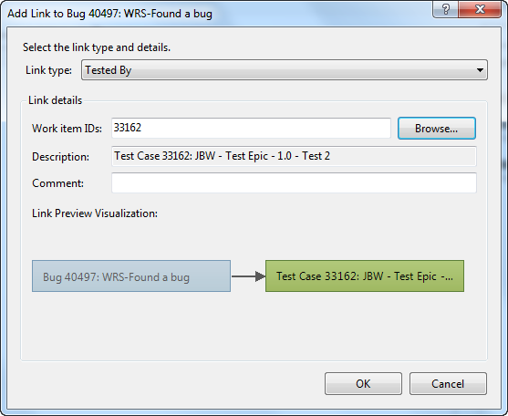

The test case(s) will be listed under Work Item ID in the link to form.

Click **OK**.

The test case(s) selected are listed under Test By in the TEST CASES section.

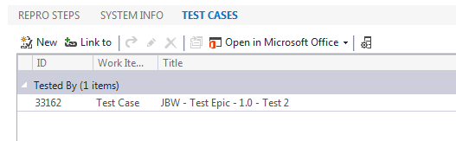

Additional Information Fields:

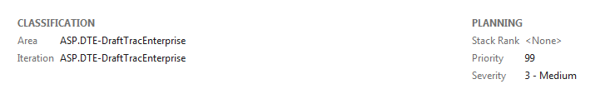

**Classification** – Select the appropriate project/team for both Area and Iteration.

**Planning**: TBD

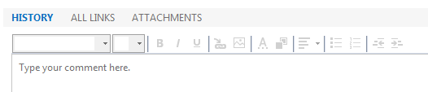

See the Reference section for details on how to use History.

**Save** the work item.

# Send to Outlook

In Team Explorer, you can also send work items to Outlook. Select the work item, then click on the Outlook icon located in the work item’s toolbar.

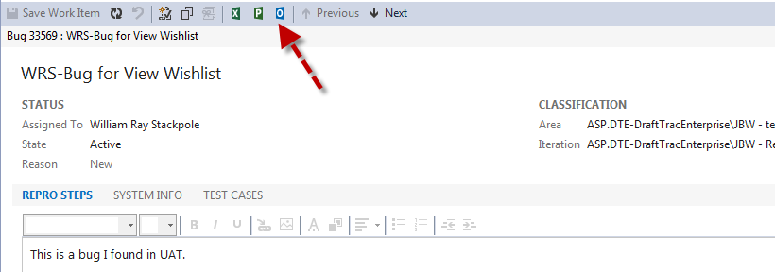

This will bring up a new email form as shown below:

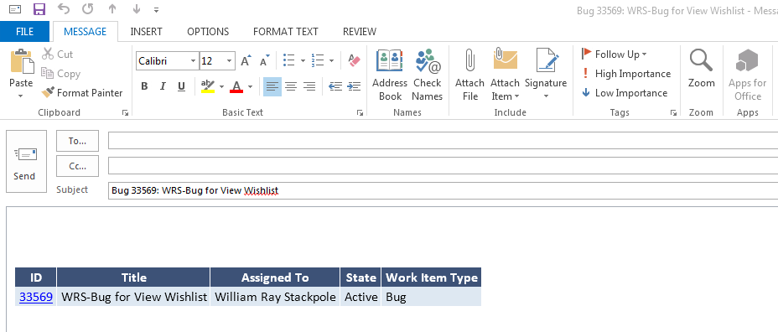

Team Explorer will insert the work item entry in the body of the email. The work item ID number is a hyperlink to TFS.

# Reference

For more information on how to use the Visual Studio 2013 tools for TFS, check out the user guide and other documentation located from the Help menu.

|  |  |
| --- | --- |
|  | **How To Add Attachments to a Work Item** |
|  | **How to work with Queries** |
|  | **How to work with History** |