DTE Release Agile Team Best Practice Guidelines
Job Aide

Prepared By: | Paul Race
Date Prepared: | 11-2-15
Date Last Updated:
Version: | 1.0

Table of Contents
Introduction 3
How to Install TFS 4
Launching Team Explorer 6
Selecting a Team Project 7
Templates 10
Queries 11
Team Queries 12
Web Portal and Dashboard 13
Create New 15
Work Items 17
How to Create Work Items 18
Saving the Work Item 26
Creating New Linked Work Items for an Epic 27
Work Item IDs 37
How to Create a Bug (work item, that is) 38
Send to Outlook 44
Reference 45

Introduction

The DTE Release Team utilization of Agile Principles has evolved from a Hybrid development approach in 2014 Q4 and 2015 Q1, to a development approach that utilizes more aspects of Agile Principles as team members are trained on Agile.
BRD – When a BRD has been generated, it is the Document of Record pertaining to Requirements and scope.
The following diagram illustrates the DTE Release Agile Process:
Product
GO-LIVE
UAT Test Cycle (MODEL)
IT-QA Regression (MODEL)
Go Live Activities

Sprint Execution Cycles

Sprint Backlog:
- User Stories refined during sprint if changes to User Story content identified by scrum team and Product Owner
Sprint Review
- Demo Epic / User Story that are DONE to Business
- Business / Product Owner ACCEPTANCE

Execute Sprint
- Daily Stand-ups
- Detailed Design (if applicable)
- Coding / Rules Changes
- QA testing of Changes
- Test Result Review to DONE

Sprint x Planning
- Based on Scrum capacity accept User Stories into Sprint Backlog

DTE Planning and Requirements

Release Backlog - User Stories Refined:
- Execution needed to reach DONE is understood
- Effort needed to reach DONE is understood
- User Stories meet size guidelines
Portfolio Mgmt Unplanned Urgent Prioritization
BA – Epic Initial User Story / Acceptance Criteria Creation
- Decomposition of Epics into business stories
- Sizing of stories
- User Story Description
- Acceptance Criteria
- Business review / approval
- Decomposition for sizing
Portfolio Mgmt / Exec Sponsors Prioritization of Epics
Intake
GO – Live Deployments
To MODEL at sprint completion based on Release Calendar

Scrum Team User Story Refinement
- High Level Design
- Initial Pass Code and Rules Dev Tasks
- Initial Pass Test Case Tasks
- Further Decomposition for sizing
Each DTE Release Cycle is made up of the following activities:
- Planning and Prioritization – 2 week duration
- Release Backlog Creation – 2 week duration
- Release Backlog Refinement – 3 week duration
- Scrum Sprints – 12 week duration (Four 3 week sprints)

Planning and Prioritization

Planning and Prioritization consists of selecting the Release Item requests, and the Production Support Item requests to be prioritized to be deployed to Production during a Release Cycle.
The Release Item requests are prioritized by the Portfolio Manager and Executive Sponsors based on the ASP IT Portfolio Management process. Committed Release Items is based on 75% of the team capacity for the Release Cycle. The remaining team capacity is reserved for Unplanned Urgent requests and scope adjustments expected with an Agile based process.
The Production Support Item requests are prioritized by the BA Production Support Lead / Product Owner based on Portfolio Management capacity allocations to Production Support for the Release Cycle.

Release Backlog Creation

A Release Backlog is created by the scrum team from the Release Item requests and Production Support Item requests prioritized as part of the Planning and Prioritization activity. The Release Item requests are Epics created by the DTE BSA team as part of the Portfolio Intake Process. Backlog creation includes initial User Story decomposition of the Epic request, authoring of the User Story description, and in collaboration with business stakeholders the representation of business requirements as Acceptance Criteria for those User Stories.
Having the Intake Process create an Epic for the Release Item request is new to the DTE Intake process as of March 2015. During a transitional period, the scrum team will find Release Item requests prioritized into a Release Cycle that do not have Epics, but that only have a Scope document attached to the Release Item PPM. For those Release Items, part of the Release Backlog Creation will be the incorporation of the scope document information into an Epic.
Release Backlog Creation for a Release Item Epic is complete when business stakeholders have reviewed and approved the User Story(ies) description, and Acceptance Criteria for that Release Item Epic request.
The expectation is that the Release Backlog Creation for all Release Item Epic requests prioritized into the Quarterly Release will be completed during the five week duration allocated for Release Backlog Creation and Release Backlog Refinement.

Unplanned Urgent Release Backlog Creation
As Unplanned Urgent requests are prioritized by executive sponsors into a Release Cycle, the scrum team will follow the process of User Story creation for those requests.

Release Backlog Refinement
Release backlog User Stories are further refined by scrum team members:
- adding high level design
- initial IT-Dev and Rules development tasks
- Initial Test tasks, Test Cases and
- possibly further decomposing the User Stories to be “right sized”.
The expectation is that 70% - 80% of the Release Backlog Refinement will be completed during Sprint 0.
The remaining Release Backlog Refinement will be completed as a background activity by the scrum team thru the early sprints of the Quarterly sprinting cycle.

Unplanned Urgent Release Backlog Refinement
As Unplanned Urgent request are prioritized by executive sponsors into a Release Cycle, and User Story creation is completed for those requests, those User Stories will be added to the list to be refined as a background activity by the scrum team during sprint execution.
Scrum Sprints
User Story execution during a scrum sprint included the following tasks:
- Detailed Design of application code and Rules (if applicable)
- Development changes of application code, Rules, Configurations, and Settings
- QA Test of development changes

Planning and Prioritization

Planning and Prioritization consists of selecting the Release Item requests, and the Production Support Item requests to be prioritized to be deployed to Production during a Release Cycle.
The Release Item requests are prioritized by the Portfolio Manager and Executive Sponsors based on the ASP IT Portfolio Management process. Committed Release Items is based on 75% of the team capacity for the Release Cycle. The remaining team capacity is reserved for Unplanned Urgent requests and scope adjustments expected with an Agile based process.
The Production Support Item requests are prioritized by the BA Production Support Lead / Product Owner based on Portfolio Management capacity allocations to Production Support for the Release Cycle.

Planning and Prioritization

Planning and Prioritization consists of selecting the Release Item requests, and the Production Support Item requests to be prioritized to be deployed to Production during a Release Cycle.
The Release Item requests are prioritized by the Portfolio Manager and Executive Sponsors based on the ASP IT Portfolio Management process. Committed Release Items is based on 75% of the team capacity for the Release Cycle. The remaining team capacity is reserved for Unplanned Urgent requests and scope adjustments expected with an Agile based process.
The Production Support Item requests are prioritized by the BA Production Support Lead / Product Owner based on Portfolio Management capacity allocations to Production Support for the Release Cycle.

Planning and Prioritization

Planning and Prioritization consists of selecting the Release Item requests, and the Production Support Item requests to be prioritized to be deployed to Production during a Release Cycle.
The Release Item requests are prioritized by the Portfolio Manager and Executive Sponsors based on the ASP IT Portfolio Management process. Committed Release Items is based on 75% of the team capacity for the Release Cycle. The remaining team capacity is reserved for Unplanned Urgent requests and scope adjustments expected with an Agile based process.
The Production Support Item requests are prioritized by the BA Production Support Lead / Product Owner based on Portfolio Management capacity allocations to Production Support for the Release Cycle.

Planning and Prioritization

Planning and Prioritization consists of selecting the Release Item requests, and the Production Support Item requests to be prioritized to be deployed to Production during a Release Cycle.
The Release Item requests are prioritized by the Portfolio Manager and Executive Sponsors based on the ASP IT Portfolio Management process. Committed Release Items is based on 75% of the team capacity for the Release Cycle. The remaining team capacity is reserved for Unplanned Urgent requests and scope adjustments expected with an Agile based process.
The Production Support Item requests are prioritized by the BA Production Support Lead / Product Owner based on Portfolio Management capacity allocations to Production Support for the Release Cycle.

Planning and Prioritization

Planning and Prioritization consists of selecting the Release Item requests, and the Production Support Item requests to be prioritized to be deployed to Production during a Release Cycle.
The Release Item requests are prioritized by the Portfolio Manager and Executive Sponsors based on the ASP IT Portfolio Management process. Committed Release Items is based on 75% of the team capacity for the Release Cycle. The remaining team capacity is reserved for Unplanned Urgent requests and scope adjustments expected with an Agile based process.
The Production Support Item requests are prioritized by the BA Production Support Lead / Product Owner based on Portfolio Management capacity allocations to Production Support for the Release Cycle.

Planning and Prioritization

Planning and Prioritization consists of selecting the Release Item requests, and the Production Support Item requests to be prioritized to be deployed to Production during a Release Cycle.
The Release Item requests are prioritized by the Portfolio Manager and Executive Sponsors based on the ASP IT Portfolio Management process. Committed Release Items is based on 75% of the team capacity for the Release Cycle. The remaining team capacity is reserved for Unplanned Urgent requests and scope adjustments expected with an Agile based process.
The Production Support Item requests are prioritized by the BA Production Support Lead / Product Owner based on Portfolio Management capacity allocations to Production Support for the Release Cycle.

Planning and Prioritization

Planning and Prioritization consists of selecting the Release Item requests, and the Production Support Item requests to be prioritized to be deployed to Production during a Release Cycle.
The Release Item requests are prioritized by the Portfolio Manager and Executive Sponsors based on the ASP IT Portfolio Management process. Committed Release Items is based on 75% of the team capacity for the Release Cycle. The remaining team capacity is reserved for Unplanned Urgent requests and scope adjustments expected with an Agile based process.
The Production Support Item requests are prioritized by the BA Production Support Lead / Product Owner based on Portfolio Management capacity allocations to Production Support for the Release Cycle.

Planning and Prioritization

Planning and Prioritization consists of selecting the Release Item requests, and the Production Support Item requests to be prioritized to be deployed to Production during a Release Cycle.
The Release Item requests are prioritized by the Portfolio Manager and Executive Sponsors based on the ASP IT Portfolio Management process. Committed Release Items is based on 75% of the team capacity for the Release Cycle. The remaining team capacity is reserved for Unplanned Urgent requests and scope adjustments expected with an Agile based process.
The Production Support Item requests are prioritized by the BA Production Support Lead / Product Owner based on Portfolio Management capacity allocations to Production Support for the Release Cycle.

Planning and Prioritization

Planning and Prioritization consists of selecting the Release Item requests, and the Production Support Item requests to be prioritized to be deployed to Production during a Release Cycle.
The Release Item requests are prioritized by the Portfolio Manager and Executive Sponsors based on the ASP IT Portfolio Management process. Committed Release Items is based on 75% of the team capacity for the Release Cycle. The remaining team capacity is reserved for Unplanned Urgent requests and scope adjustments expected with an Agile based process.
The Production Support Item requests are prioritized by the BA Production Support Lead / Product Owner based on Portfolio Management capacity allocations to Production Support for the Release Cycle.

Planning and Prioritization

Planning and Prioritization consists of selecting the Release Item requests, and the Production Support Item requests to be prioritized to be deployed to Production during a Release Cycle.
The Release Item requests are prioritized by the Portfolio Manager and Executive Sponsors based on the ASP IT Portfolio Management process. Committed Release Items is based on 75% of the team capacity for the Release Cycle. The remaining team capacity is reserved for Unplanned Urgent requests and scope adjustments expected with an Agile based process.
The Production Support Item requests are prioritized by the BA Production Support Lead / Product Owner based on Portfolio Management capacity allocations to Production Support for the Release Cycle.

Planning and Prioritization

Planning and Prioritization consists of selecting the Release Item requests, and the Production Support Item requests to be prioritized to be deployed to Production during a Release Cycle.
The Release Item requests are prioritized by the Portfolio Manager and Executive Sponsors based on the ASP IT Portfolio Management process. Committed Release Items is based on 75% of the team capacity for the Release Cycle. The remaining team capacity is reserved for Unplanned Urgent requests and scope adjustments expected with an Agile based process.
The Production Support Item requests are prioritized by the BA Production Support Lead / Product Owner based on Portfolio Management capacity allocations to Production Support for the Release Cycle.

Planning and Prioritization

Planning and Prioritization consists of selecting the Release Item requests, and the Production Support Item requests to be prioritized to be deployed to Production during a Release Cycle.
The Release Item requests are prioritized by the Portfolio Manager and Executive Sponsors based on the ASP IT Portfolio Management process. Committed Release Items is based on 75% of the team capacity for the Release Cycle. The remaining team capacity is reserved for Unplanned Urgent requests and scope adjustments expected with an Agile based process.
The Production Support Item requests are prioritized by the BA Production Support Lead / Product Owner based on Portfolio Management capacity allocations to Production Support for the Release Cycle.

Planning and Prioritization

Planning and Prioritization consists of selecting the Release Item requests, and the Production Support Item requests to be prioritized to be deployed to Production during a Release Cycle.
The Release Item requests are prioritized by the Portfolio Manager and Executive Sponsors based on the ASP IT Portfolio Management process. Committed Release Items is based on 75% of the team capacity for the Release Cycle. The remaining team capacity is reserved for Unplanned Urgent requests and scope adjustments expected with an Agile based process.
The Production Support Item requests are prioritized by the BA Production Support Lead / Product Owner based on Portfolio Management capacity allocations to Production Support for the Release Cycle.

Planning and Prioritization

Planning and Prioritization consists of selecting the Release Item requests, and the Production Support Item requests to be prioritized to be deployed to Production during a Release Cycle.
The Release Item requests are prioritized by the Portfolio Manager and Executive Sponsors based on the ASP IT Portfolio Management process. Committed Release Items is based on 75% of the team capacity for the Release Cycle. The remaining team capacity is reserved for Unplanned Urgent requests and scope adjustments expected with an Agile based process.
The Production Support Item requests are prioritized by the BA Production Support Lead / Product Owner based on Portfolio Management capacity allocations to Production Support for the Release Cycle.

Planning and Prioritization

Planning and Prioritization consists of selecting the Release Item requests, and the Production Support Item requests to be prioritized to be deployed to Production during a Release Cycle.
The Release Item requests are prioritized by the Portfolio Manager and Executive Sponsors based on the ASP IT Portfolio Management process. Committed Release Items is based on 75% of the team capacity for the Release Cycle. The remaining team capacity is reserved for Unplanned Urgent requests and scope adjustments expected with an Agile based process.
The Production Support Item requests are prioritized by the BA Production Support Lead / Product Owner based on Portfolio Management capacity allocations to Production Support for the Release Cycle.

Once you click the Download button, you’ll want to select the first checkbox - the exe and not the ISO and run it.
Once the exe runs, select the first checkbox for accepting the terms of use & deselect the second checkbox labeled ‘Join the experience program’.
If at any point the installation asks you to create a Microsoft account select ‘Not Now – Later’.

During the install process, the program will caution you about compatibility. This is because Team Explorer uses Internet Explorer as its default browser. If you currently have IE8 installed and set as your default browser, then you’ll want to use a different browser (for instance Chrome) to access the web portal. IE8 works, but not all of the features of TFS are supported in IE8.
Once the installation is complete, you should be able to open TFS which will be located under Visual Studio 2013 in the Windows Start menu.

Launching Team Explorer

You’ll launch TFS from the Start menu – it’s under Microsoft Visual Studio 2013:
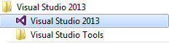

Hint: You can pin the program to your task bar for easy access.
You may see a message the first time you select a team project. It says ‘You must configure your workspace mappings to open solutions for this project.’ Just click the ‘x’ for this. Configuring the workspace isn’t needed for managing work items and has to do more with development activities. (If you do click it, then expect the mapping process to take approximately 30 minutes to map all of the network drives.)
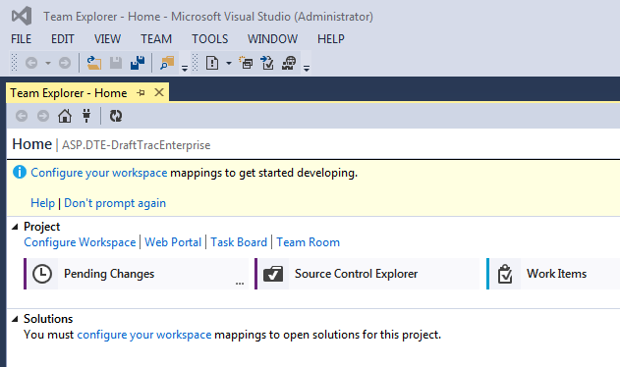

Note: This is the IDE view of TFS. IDE stands for Integrated Development Environment. It’s also called Team Explorer. We’ll use Team Explorer as a reference to this facility in the rest of this document.

Selecting a Team Project

Your default project is ASP.DTE-DraftTracEnterprise. If you want to open a different project, click the down arrow at the far right of the screen on the row Labeled Home.
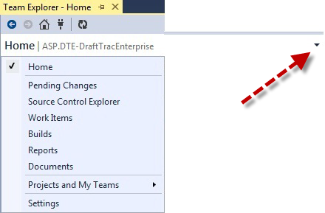

Select Projects and My Teams, then Connect to Team Projects…
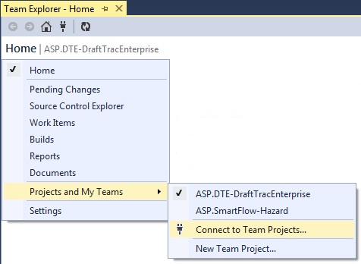

Hint: You can also click on the little plug icon in the toolbar to access this function.
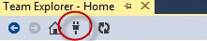

The Connect screen will appear. Click on Select Team Projects…
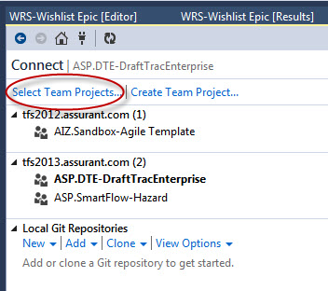

Note: On this screen you’ll see the projects that you currently have pinned to your Team Explorer workspace. The one that has focus is shown in Bold.
Note: Depending upon your security access level, you may or may not be able to use the Create Team Project feature.
Put a checkmark in the box next to the project(s) you want to use.
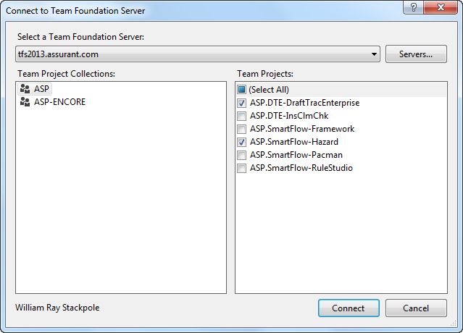
Let’s choose ASP.DTE-InsClmChk. Click Connect to add this project to our list.
Now, it’s in our list of projects, and it has focus. A project with focus in Team Explorer is the one that provides you with a specific project template. We’ll see how templates work in the next section.
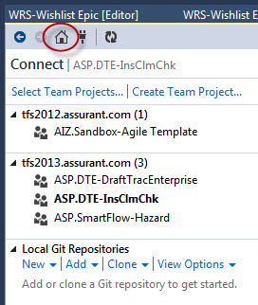 | To remove a project from the list, click Select Team Projects and uncheck the box next to that project.  Click the Home icon (the little house icon in the toolbar) to return to the main menu.

Templates

Each project can have its own template. A template is a project design configuration that provides the user with a specific set of work items and features. This makes sure that only the appropriate work items are entered on this project. For example, here are two projects each with a specific template:
SmartFlow Template | DTE Template

Queries

Team Explorer provides a robust query facility that allows the user to access work items in their projects. This job aide does not spend a lot of time on how to use queries. For quick reference, there is a document entitled How to work with Queries located in the Reference section of this document.
To get to the query functions, click on the Home icon to return to the main Home menu. Then, click on Work Items on the menu bar.
This brings up the Work Items functions menu.
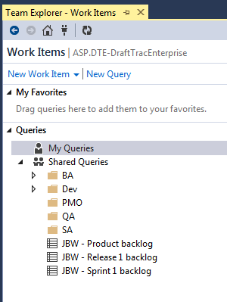

My Favorites – frequently used queries that show record counts without having to run them.
My Queries – Queries that you have created – only you can see them.
Shared Queries – Queries that are used by the team. These are broken down by role. Anyone can run these.

Team Queries

Management has designed a set of queries that will help the team search out work items for their projects. You can find these under Sharded Queries in the PMO folder. These are often referred to as Team Favorites and are queries that are frequently used by the team.
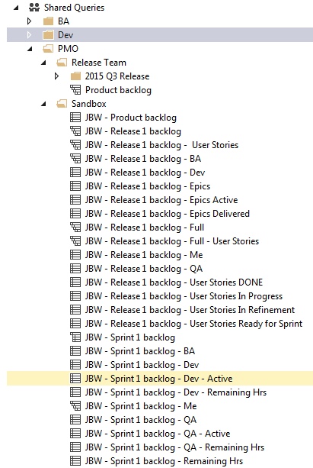

Web Portal and Dashboard

The web portal (officially known as Team Web Access or TWA) is really a team dashboard. It’s an easy way for management and team members to get the “Big Picture” about what’s going on with the project.
You can get to the web portal from Team Explorer by clicking the Web Portal link:
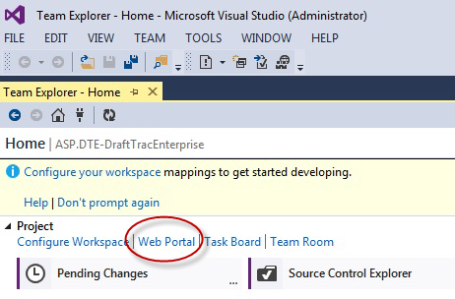

Caution: Internet Explorer 8 is not supported by Visual Studio 2013. Some of the fucntions will work, but not all. It’s best to launch the web portal from a supported bowser like Chrome.
To get to the web portal without these problems, open up your Chrome browser and use the following URL:
http://tfs2013.assurant.com:8080/tfs/ASP/ASP.DTE-DraftTracEnterprise

TFS Dashboard
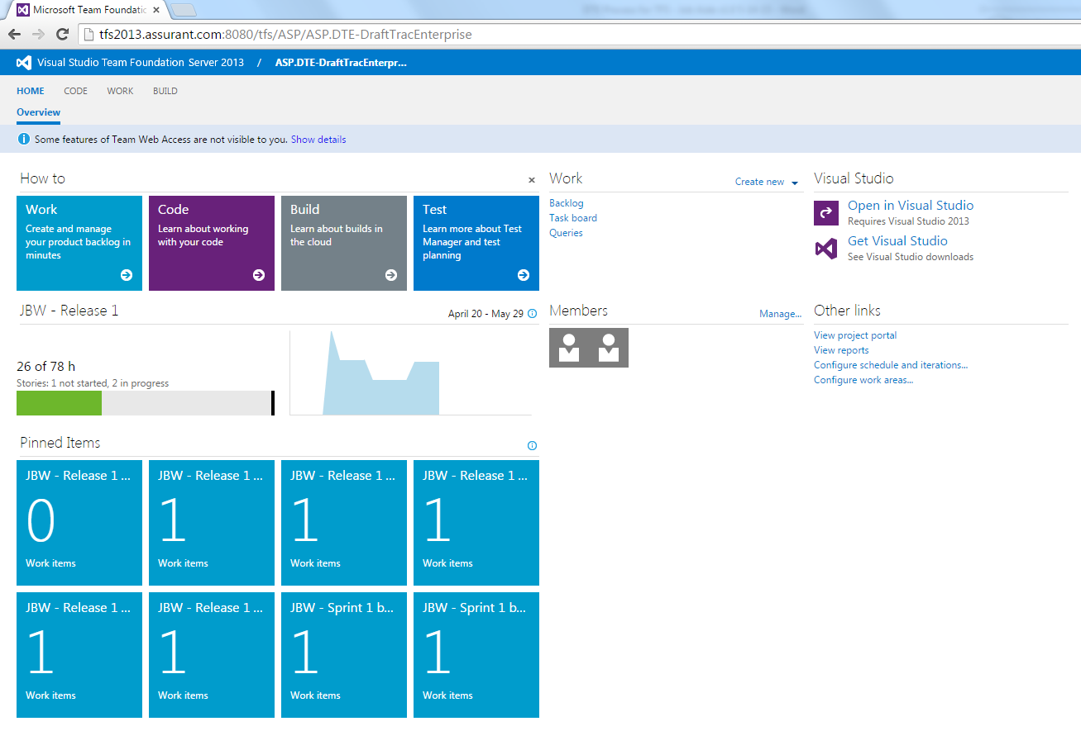
NOTE: Management is still deciding on the best components that they want to show on this page to help the teams. It’s likely that all teams will have the same dashboard configuration initially, then management will how each team evolves to use different data in their processes.

Typical features of this dashboard are the How Tos shown at the top of the screen, bar and pie charts of the team Burndown in the middle, and blocked labeled Pinned Items which are in fact the results from the team queries.

You can switch to another project area by clicking on the current project name to get the others that are in your project list.
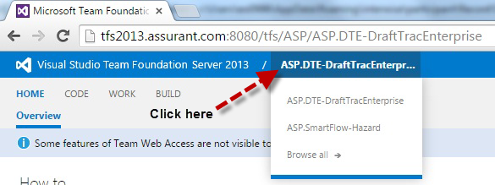

Create New

You can create new work items from this page. The dialog boxes look different than Team Explorer, but the results are the same.
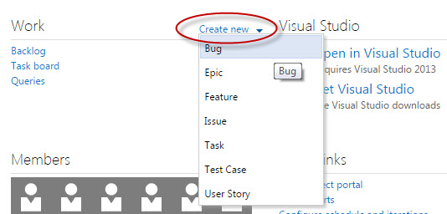

You’ll probably work in the Team Explorer screens when creating or managing work items. For quick access to TFS, pin the application to your task bar in Windows.
On the main tab menu at the top, you have Home, then Code (not covered here), and then Work, which shows you the user stories that have been added and not worked, and those that are in-progress.
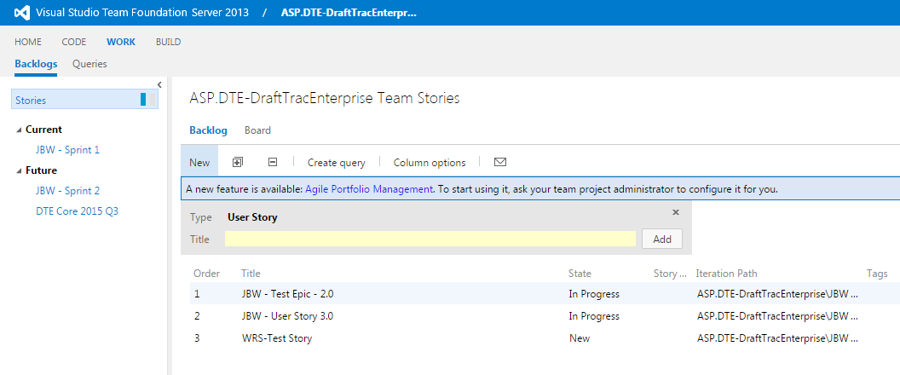
In this view, you can change the order of the stories simply by moving the entry up and down the list. – Caution: All TFS activities are logged, so they will know which user did this.

Work Items

A Work Item is a generic term used in TFS to denote either a placeholder or a specific activity. Team Explorer makes it easy to create, modify, and locate work items.
Work item types that you’ll use are:
- Bug – used to document/report problems within the software.
- Task – specific, measureable elements that are tracked. There are one or many tasks under a user story and they represent the work needed to complete the user story.
- User Story – A story is an individual feature or requirement that the business wants. It is something that is deliverable (i.e. production ready) within a single sprint. The elements of a story. Stepping stones to take the story to ‘Done’. Tasks often follow the SMART acronym: specific, measurable, achievable, relevant, time-boxed (although what the letters stand for seems to be hotly debated).

- Epic – An epic is a big story. A requirement that is just too big to deliver in a single sprint. Epics need to be broken into smaller deliverables (stories). This helps them support the agile principles (e.g. delivering working software frequently, early continuous delivery, regular reflection).
- Feature – (Not currently used)
- Issue - (Not currently used)
- Test Case – the specific testing QA will perform. There are one or many test cases for each user story to test the user story’s acceptance criteria.

How to Create Work Items

Follow the steps below and on the next few pages to create an Epic work item in TFS. This tutorial walks you through creating the Epic, it’s linked User Stories, and the Tasks linked to each User Story.
In Team Explorer, click on the Work Items tab on the Home page.
Click on New Work Item.
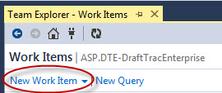
You’ll see the list of work item types available in this project template.
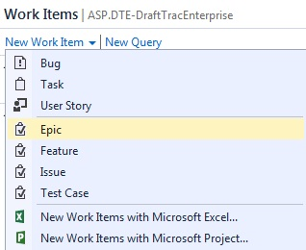

Choose Epic
Before we fill in the details about this epic, let’s take a look at the naming convention for this type of work item. The Title of the Epic should be in the following format:
PPM ppm number – brief description
Example: PPM 310316 – Client Specific Setup
Now, name the work item using the standard naming convention in the space with the <Enter title here> prompt.
Next, fill in the details for this work item under Details.
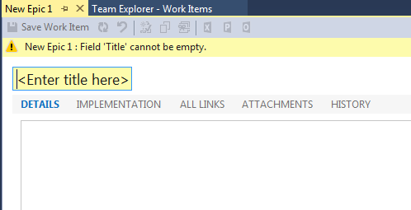

Click on IMPLEMENTATION
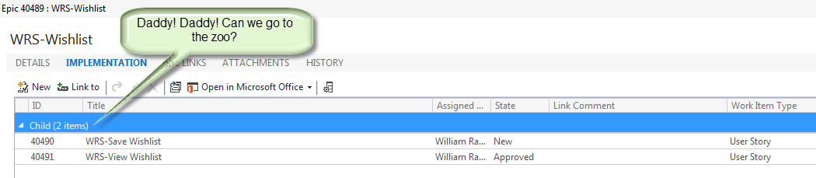
This form lists all the children (user stories) that are linked to this epic. (We’ll come back to this function when we create the User Stories for this Epic.)

Click on ALL LINKS
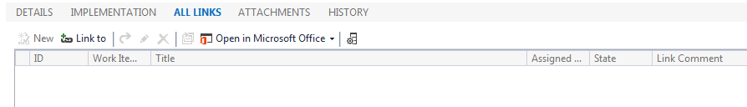
This form shows the parents (epics), their children (user stories), and other related work items for this epic.

Click on ATTACHMENTS
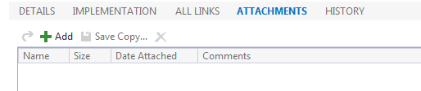
This form shows you any attachments associated with this work item. For an explanation of how to add an Attachment, see the ‘How To Add Attachments to a Work Item‘ procedure located in the Reference section at the end of this job aide.

Click on HISTORY
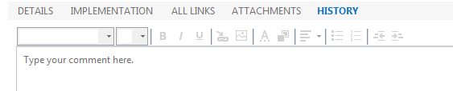
This feature shows you the log for this work item that contains every activity posted against it. For an explanation of how to work with the History log, see the ‘How To Work with History‘ procedure located in the Reference section at the end of this job aide.

To the right of the Details entry space, you’ll see additional fields for this work item. There are three sections: Status, Planning, and Classification. Not all of these are used for DTE epics. On the next few pages we’ll show what to fill out in each of these fields.
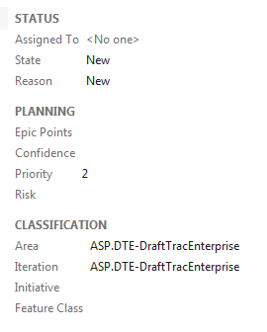

STATUS
Assigned To
This field lets you assign the Epic to a user. Mouse over the text <No one> to the right of the Assigned To prompt and you’ll see a dropdown arrow. Click the arrow to get a list of all available TFS users on this project appears.
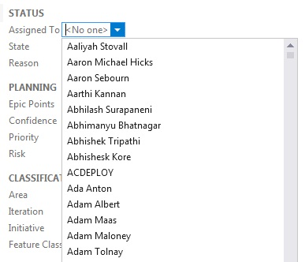
You can scroll through the list and pick a name. The names are in alphabetical order by First and Last name. Once you select a name it will appear in the Assigned To entry field.
Another way to enter the name is to click on the <No one> box and start typing the name. TFS will find the closest name to the letter you type.

State
State represents the status of this work item. All new work items are marked New.
For Epics, there are two scenarios where the state change from one status to another varies. These are for Product releases and Backlog releases.
In a Product release, the work item state goes from New to Active when the business analyst begins to gather information for the Scope Analysis document. The state remains in Active status until the item is Removed, or it is approved.
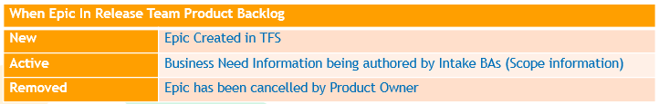

If the Epic transitions into a backlog item (it’s approved to move forward as a project), then the Active state remains while business requirements are gathered. User stories are created during this state.
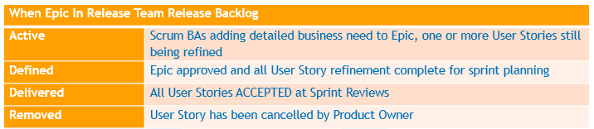
Once the Epic is approved (business requirements have been completed and approved, and the user stories are done), then we’ll see the state move to Defined.
The epic moves to a Delivered state after all the user stories have been accepted.
The graphic on the next page represents the state changes for an Epic work item type.

EPIC State Changes in the TFS process

Reason – Not currently used.
PLANNING
Epic Points – not currently used

Confidence – The preset percentages allow you to note the level of confidence the team has in completing this epic. - not currently used | 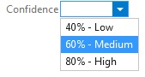
Priority – Preset priority choices for ordering the epic within the project. | 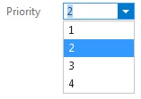
Risk – Preset risk levels to represent the inherent challenges in completing this epic. | 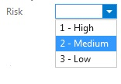

CLASSIFICATION
Area – defines the team. | DTE Core Release Team
Iteration – defines the release. | 2015 R4 – June (example)
Initiative – not currently used | 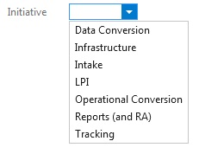
Feature Class – not currently used

Saving the Work Item
After all the work item information has been entered, you need to Save the work item to the TFS database.

Creating New Linked Work Items for an Epic

As we saw before, the Implementation form lists all the children (user stories) that are linked to an epic. We could use the long method to add User Stories to our Epic (i.e., create the Epic, then create the User Story, then create the Task(s), and after all that is done, link the work items together). Or, we could employee the New Linked Work Item feature to create our User Story while we’re still working with the Epic.
First, save the work item. After the save, click on IMPLEMENTATION. You’ll see the New Linked Work Item command has been enabled.
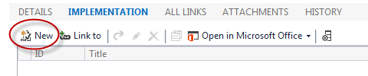
Click on New to bring up the work item link screen.
Note: There is also a naming conventions for User Story titles:
The Title of User Stories associated with an Epic should be the following format:
PPM ppm number - User Story Number Short Description of User Story
Production Support Requests prioritized into a Release Cycle, will be represented in the Release Backlog as a User Story. The Title of the User Story should be the following format:
Prod Support ppm number - PPM Short Description

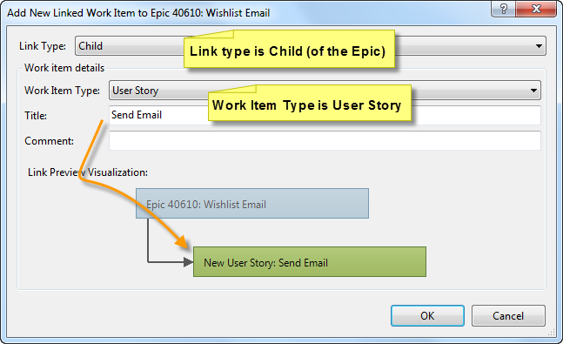

Link Type should be Child (remember: we are creating a Child work item, a User Story, to our parent work item, an Epic).
Select the Work Item Type as User Story.
Fill in the Title using the naming convention.
Comment is optional.
Click OK.

The New User Story entry screen will appear. Enter your user story description under Details. In this section, include the actual user story, acceptance criteria and assumptions, risks, constraints and dependencies.
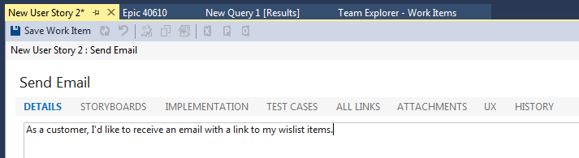

Save this work item before moving on to the next step.

STORYBOARDS – Not currently required.
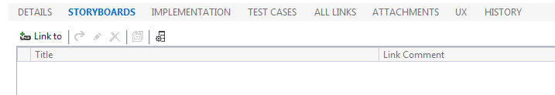
TEST CASES - The DTE Team should not be required to create new Test Cases. However, you’ll have an opportunity to view the test cases entered by IT/QA through the web portal.
ALL LINKS shows all related work items (parents, children, etc.)
See the Reference section for instructions on how to add attachments and work with History.
Next, we’ll fill in the additional information for this User Story.

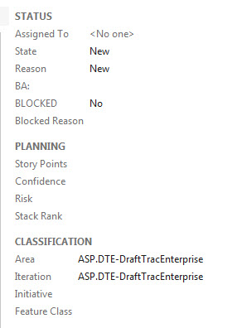

Status
Assigned To – use the same method that we did for the Epic work item.

State
State represents the status of this work item. All new work items are marked New. For User Stories, there are three scenarios where the state change from one status to another varies. These are for Product Backlog, Release Backlog and Sprint Backlog. Below are the State designations for each phase:
When User Story In Release Team Product Backlog
New | Initial User Story being authored by Intake BAs

When User Story In Release Team Release Backlog
New | User Story / Acceptance Criteria being authored by Scrum BAs
Approved | User Story / Acceptance Criteria ready for Task Refinement and reviewed with business stakeholders
In Analysis | User Story Task Refinement in progress
Ready | User Story refined to point that it is ready for sprint planning
Removed | User Story has been cancelled by Product Owner

When in User Story in Release Team Sprint Backlog
Committed | User Story not being worked
In Progress | User Story actively being worked by IT-DEV or RULES
In Progress | All IT-DEV and RULES tasks ready for test, but User Story not being tested
In Progress | QA test in progress
In Progress | All QA tests PASSED, but BA review not complete
DONE | BA reviewed test results and claimed DONE, User Story targeted for sprint review  (In Template – status indicates PO accepted)
 | PO and stakeholders accepted DONE status at sprint review (Not in Template)
Removed | User Story has been cancelled by Product Owner

The graphic below represents the state changes for an Epic work item type.

User Story State Changes in the TFS process

Reason – read only – reason for the most recent state.
BA – SCRUM team BA assigned to this user story.
Blocked – Yes/No
Blocked Reason - Free form reason for user story being blocked. Example: waiting on dependency, environmental issues, any impediment(s).

Planning – not used
Stack Rank – not used

Classification
Area – designates the SCRUM team name.
Iteration – the release or sprint.
Initiative – not used
Feature Class – not used

Save this work item before moving on to the next step.

Next, click IMPLEMENTATION. We’re going to add the tasks to this user story.
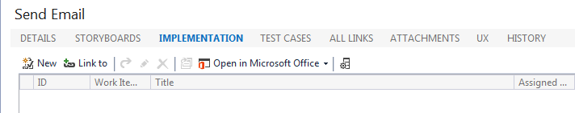
Just like we did for the Epic, we’ll use the New Linked Work Item feature to add our Tasks to this user story. Click New.
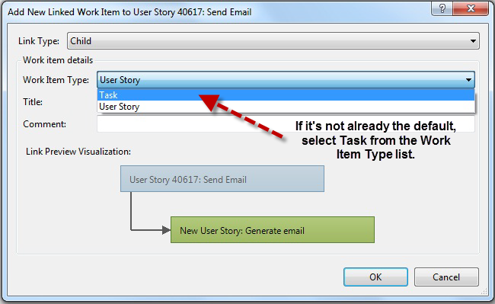

Fill in the Title for this task.
Click OK.
The New Task entry screen will appear. Enter your task details under Description.
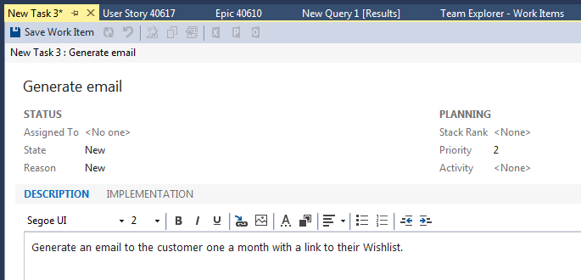

Additional Fields for Tasks:
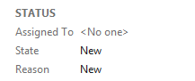
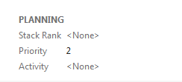 | Not used
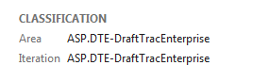 | Inherited from User story
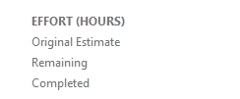 | Fill in Original Estimate  Remaining – entered by user  Completed – entered by user

State
When Task In Release Team Release Backlog
New | Task being authored or has been authored by Scrum Team
Removed | Task has been cancelled by Scrum Team
When Task In Release Team Sprint Backlog
New | Execution of task has not started
Active | Task being executed
Closed | Task execution complete
Removed | Task has been cancelled by Scrum Team

Task State Changes in the TFS process

Save the work item.

Work Item IDs

As the work item is saved, TFS assigns it a unique ID number. This number refers to this work item and is unique across all TFS projects.
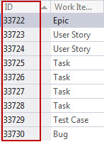

How to Create a Bug (work item, that is)

Follow the steps below and on the next few pages to create a Bug work item in TFS.
In Team Explorer, click on the Work Items tab on the Home page.
Click on New Work Item.
Choose Bug.
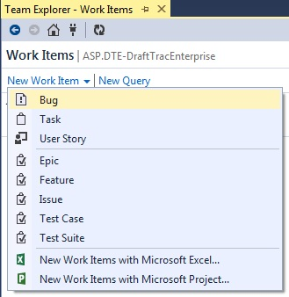

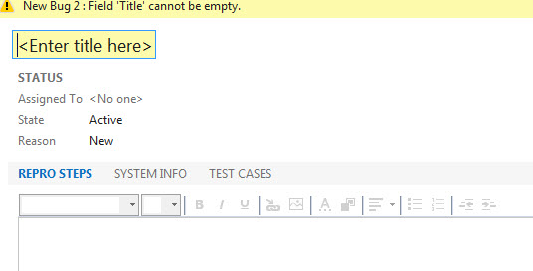
Enter a Title for this work item.
Enter the steps to reproduce the bug under REPRO.
Next, click SYSTEM INFO.
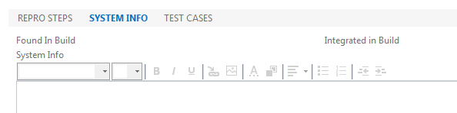
Enter any information like systems variables that would cause the bug. These could include loan#, tracking number, userid, ad other systems variables.
Click on TEST CASES.
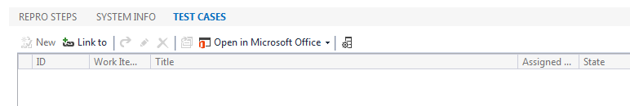
Use the Link to feature to locate and associate a test case with this bug. You will get the Add Link to New Bug dialog screen as shown on the next page.
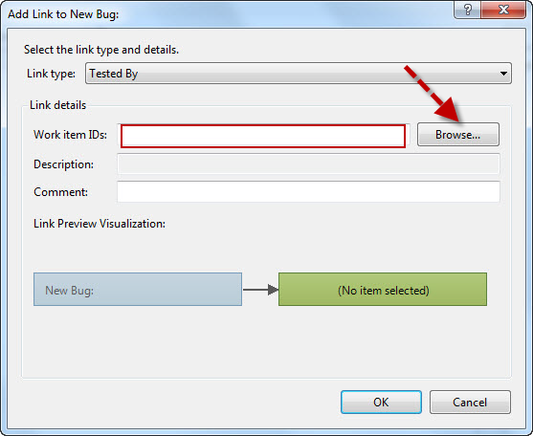
The Link Type will default to Tested By. This shows that this bug is associated with a Test Case.
Under Link details, you can enter in the number of the work item that was assigned to the test case in the entry field labeled Work item ID. There’s several ways to select these:
- Type in the work item ID# for the desired test case in the field. If there is more than one test case to be used, type in the list of work item numbers separated by commas.
- Click on Browse to bring up the

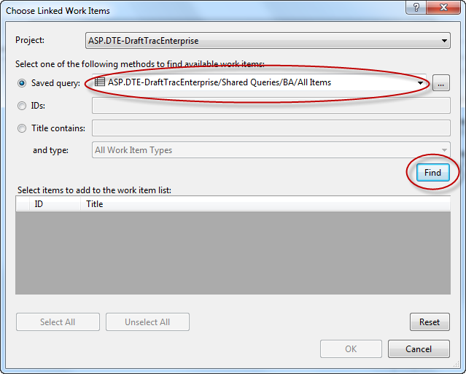
Find a saved query and click Find to run it. The query results will be displayed in the Select items pane as shown below.
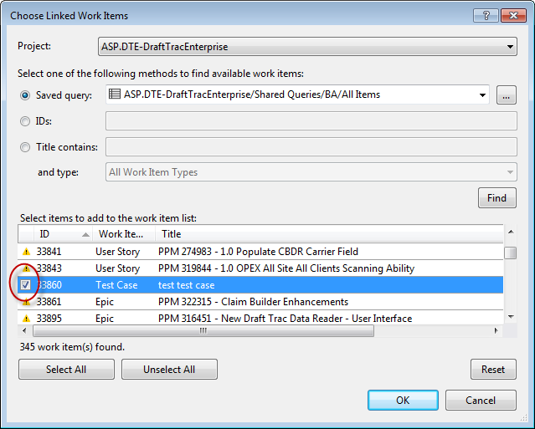
Mark the checkbox next to the test case(s) you want and click OK.
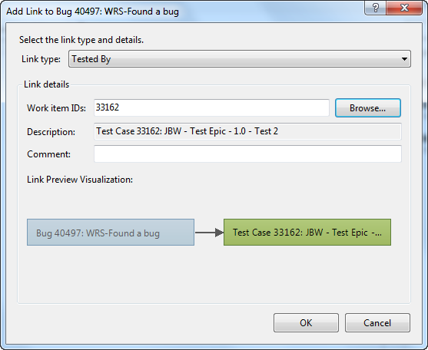
The test case(s) will be listed under Work Item ID in the link to form.
Click OK.
The test case(s) selected are listed under Test By in the TEST CASES section.
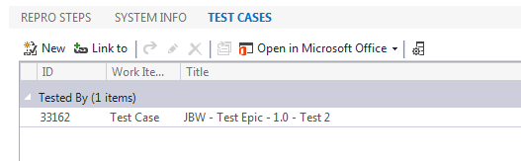

Additional Information Fields:
Classification – Select the appropriate project/team for both Area and Iteration.

Planning: TBD

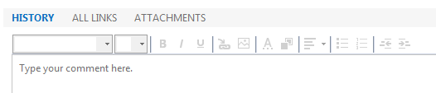
See the Reference section for details on how to use History.
Save the work item.

Send to Outlook

In Team Explorer, you can also send work items to Outlook. Select the work item, then click on the Outlook icon located in the work item’s toolbar.
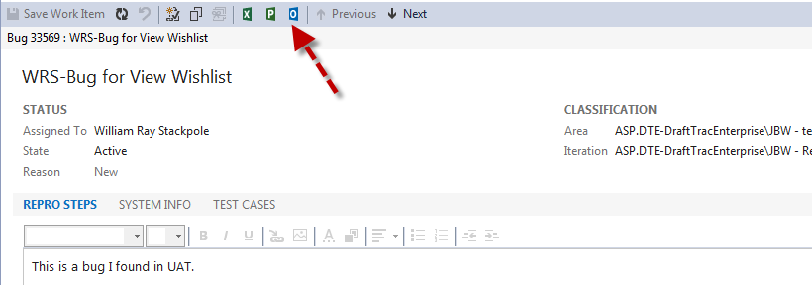

This will bring up a new email form as shown below:
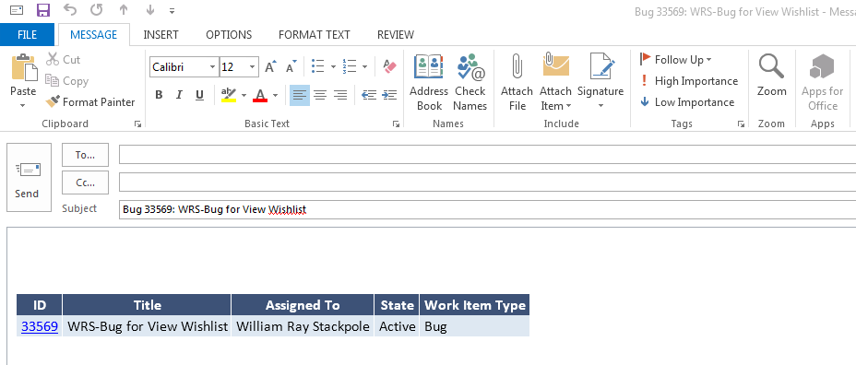
Team Explorer will insert the work item entry in the body of the email. The work item ID number is a hyperlink to TFS.

Reference

For more information on how to use the Visual Studio 2013 tools for TFS, check out the user guide and other documentation located from the Help menu.
How To Add Attachments to a Work Item
How to work with Queries
How to work with History

