
SmartFlow Agile Team Best Practice
Job Aide

Prepared By: | Paul Race
Date Prepared: | 1-27-16
Date Last Updated: | 2-22-16
Version: | 1.0

Table of Contents
Introduction 4
Process and Role Flowchart: 5
Portfolio Manager/Executive Sponsor Responsibilities: 7
Resource Manager Responsibilities (Ongoing): 8
Product Owner/Stakeholders/Business Analysts Responsibilities: 9
Prioritizing Defects for Sprint Planning 9
Sprint Planning 10
Release Manager Responsibilities: 11
Indicate Go-Live commitment for Each Epic in Release Backlog 11
Prioritizing Epics Within the Release 11
Defining Epic Priorities Within TFS 12
Business Analyst Responsibilities 13
Document Requirements at the Epic Level 13
Requirements Documentation at User Story Level 13
Scrum Master Responsibilities 14
Spring Planning 14
Scrum Team Members/Responsibilities 15
Defining and Monitoring Task Priority 17
User Story Refinement During a Sprint 17
Defining DONE 18
Tracking Effort Completed and Effort ToDo 18
Sprint Review Guidelines 18
QA Responsibilities 19
Pre-Sprint 19
During Sprint 19
Ensuring “Definition of DONE” 19
Handling Test Case Failure 19
Handling the Failure of a Test Case Execution 20
If a Test Case Fails While the Sprint is Still Ongoing 20
If a Testing Support Task Fails 20
Recording Test Cases in TFS 21
Documentating Test Cases at FIT User Story Level 22
Signing Off Test Results 22
Go-Live Procedures 23
Production Go-Lives During a Release Cycle 23
Go-Live Regression / Business Acceptance Testing 23
Go-Live Prep, Production Go-Live Weekend, Warranty 23
Rules Design Documentation at User Story Level 24
Defect Tracking 25
Defect Tracking During a Sprint 25
Deferring defects from a sprint 25
Creating Bug Work Items for defects resolved in a sprint 25
Defect Tracking During UAT 25
Defect Tracking During Regression 26
Defect Tracking During Warranty 27
Processing Defects when closing the Release Backlog 28
TFS Template for Bug Work Items 29
Defect State and Reason 29
Defect Severity 30
Bug Annotation 30
TFS Project Dashboard 31
Appendix A: Creating Epics and User Stories 32
Guideline for User Story Size 32
User Story Deconstruction 33
User Story Refinement 33
Appendix B: TFS Test Case Tracking and Recording 34

Introduction

Assurant Specialty Products’ software development process uses Agile principles to promote accountability, visibility, and adaptability.
Many of the processes and procedures described in this document use “Scrum” principles developed by Jeff Sutherland. However, several have been adapted to meet specific business needs of Assurant Specialty Products

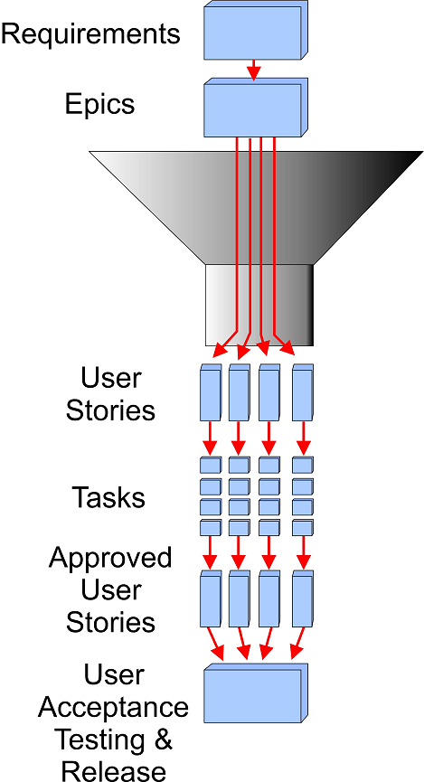
Requirement Intake and Flow:
Assurant’s Scrum implementation defines a specific process for receiving, right-sizing, and prioritizing requirements, then developing corresponding solutions.
- Identifying and defining product Requirements, including:
  - Accepting large or high-level requirements, called Epics.
  - Breaking Epics down into smaller, more manageable User Stories.
- Developing solutions, including:
  - Breaking User Stories into Tasks
  - Testing
  - Demonstrating
- Implementation, including:
  - Regression testing
  - Acceptance testing
  - “Go-Live”

Agile Scrum Roles
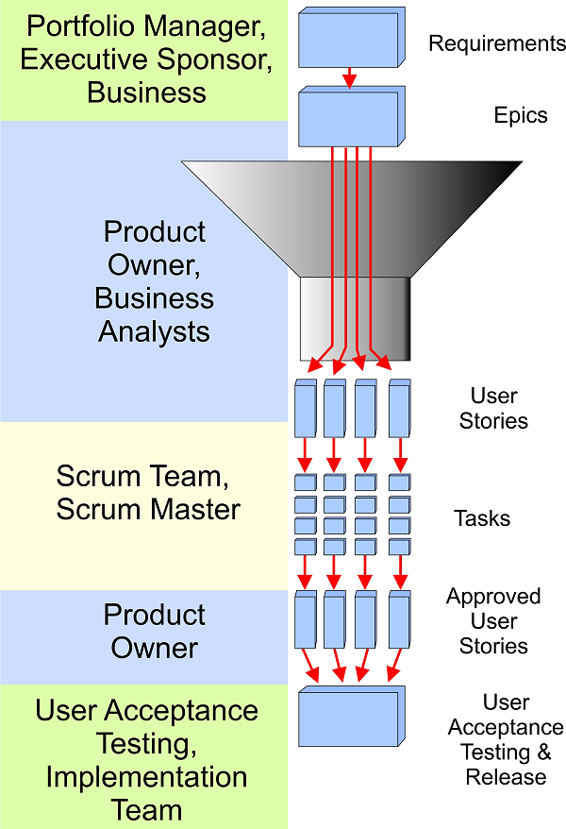
Roles involved in this process include:
- Stakeholders who have input into the requirements process, including Portfolio Manager, Executive Sponsor, Business
- Product Owner – responsible for managing the User Story backlog and signing off on completed User Stories
- Business Analysts – assist in prioritizing and “fine-tuning” User stories, including making certain they have appropriate Acceptance Criteria
- Scrum Team – a self-governing cross-functional team that is responsible for development, testing, and demonstrating finished User Stories
- Scrum Master – Facilitates Scrum planning and brief daily Scrum team meetings called “standups.”

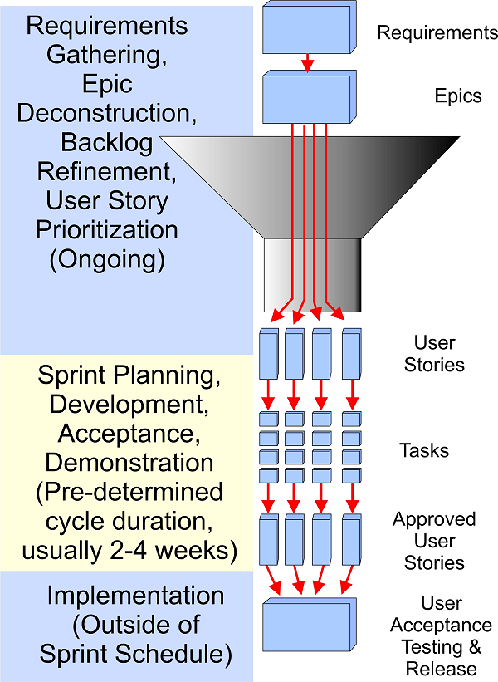
Agile Scrum Chronology
The timeframe for each of the activities listed above is as follows:
Ongoing Requirements Planning, continuous, includes:
- Requirements Gathering,
- Epic Deconstruction (Breaking large requirements into manageable User Stories
- User Story Prioritization
- Backlog Refinement (Continuous revisiting of the Epics and User Stories to make certain they are still relevant and correctly prioritized)
Sprint, predetermined short duration cycles, usually 2-4 weeks, includes:
- Sprint Planning (usually ~ 1 day)
- Development
- Acceptance (testing delivered code/function against Acceptance Criteria)
- Demonstration (to team and Product Owner)
Implementation, outside sprint development cycle, predetermined short duration cycles, usually 2-4 weeks, includes:
- User Acceptance Testing & Release

Quarterly Sprint Schedule:
As currently planned, each Quarterly Release Cycle is made up of the following activities:
- Planning and Prioritization – 2 week duration
- Release Backlog Creation – 2 week duration
- Release Backlog Refinement – 3 week duration
- Scrum Sprints – 12 week duration (Four 3 week sprints)

Portfolio Manager/Executive Sponsor Responsibilities:
High-level planning involves prioritizing feature and upgrade requests, usually at the PPM level.
Roles | Responsibilities | Resources
PMO - Portfolio Manager | Work with Resource Managers to confirm Release/Project Capacity | Inventory & Release Reports
PMO - Portfolio Manager | Interface with Executive Sponsors to Facilitate prioritization of non-production support work into the Release (at the PPM level) | Inventory & Release Reports
Executive Sponsors  Release Item Product Owner | Make decisions needed to balance demand with capacity in order to Prioritize Large Projects and Release Items into each Release Cycle | Release Report

Resource Manager Responsibilities (Ongoing):
Though many of the responsibilities described in this document relate to releases and sprints, the responsibility of managers over their assigned resources is ongoing, as follows:
Roles | Responsibilities | Resources
Resource Managers (All Groups) | Ensure team is aware of work list, assignments, priorities and due dates | Release Report
Resource Managers (All Groups) | Manage team members, remove obstacles, escalate issues to ensure work is delivered on time and with high quality | PPM & Release Report
Resource Managers (All Groups) | Ensure team members are booking time to correct PPM records (if doing work to support a specific ppm, book time to that not perpetual) | PPM & Release Report

Product Owner/Stakeholders/Business Analysts Responsibilities:
Once product requirements have been identified and prioritized at the high level, the Product Owner coordinates with Stakeholders and BAs as needed to
- Create the Product Backlog.
- Consult with BAs on deconstruction of Epics into User Stories.
- Achieve Stakeholder approval of the User Story descriptions and Acceptance Criteria associated with each Epic by business.
- Approve the Release Backlog.
- Once the Sprints are underway, approve the User Stories implemented in each Sprint.

Roles | Responsibilities | Resources
BA Manager and Product Owner | Prioritization of Release Backlog  (prioritization of user stories generated for PPM's prioritized for the Release)  (prioritization of Production Support Items for the Release)  Works with Customers/Requestors to provide direction for team (Ensure Approval of High Level Design, Answer questions, Make decisions, Support the team)  Facilitate User Story Review and Approvals with business | Inventory & Release Reports  TFS

Prioritizing Defects for Sprint Planning
Bug Work Items added to a Release Backlog during sprint execution, are considered for acceptance during sprint planning along with User Story Work Items.
The Product Owner needs to be continually prioritizing the Bug Work Items in the Release Backlog along with User Stories in the Release Backlog to give guidance during sprint planning. For consistency, prior to each sprint planning meeting, the Product Owner will update the Bug Work Item priorities in the Release Backlog into the same four buckets used for User Story prioritization. See the section “User Story Priority” for explanation of prioritization and usage of “Stack Rank” field.

Sprint Planning
Prior to each sprint planning meeting, the Product Owner will update the User Story priorities in the Release Backlog to the following four buckets:
- HIGH – must be added to the next sprint backlog
- MEDIUM – Tier 2 priority to consider to be added to the next sprint backlog
- LOW – Tier 3 priority to consider to be added to the next sprint backlog
- BLOCKED – not a candidate to be added to the next sprint backlog (BLOCKING issue should be documented in BLOCKED field of User Story)
In TFS, the “Stack Rank” field will be used to represent User Story Priority:
- Stack Rank of “1” - HIGH – must be added to the next sprint backlog
- Stack Rank of “2” - MEDIUM – Tier 2 priority to consider to be added to the next sprint backlog
- Stack Rank of “3” - LOW – Tier 3 priority to consider to be added to the next sprint backlog
- Stack Rank of “4” - BLOCKED – not a candidate to be added to the next sprint backlog (BLOCKING issue should be documented in BLOCKED field of User Story)

Note: More information about creating Epics and User Stories is provided in Appendix A: Creating Epics and User Stories
Note: Additional instructions for performing the TFS tasks related to these processes are “to be added.”

Release Manager Responsibilities:
Release managers work with Scrum Masters and BAs to transition requirements into specific releases, and to prioritize them within the release. Responsibilities include:
- Selecting the Release Item and Production Support Item requests to be deployed to Production during a Release Cycle.
- Prioritizing the Release Item requests based on the ASP IT Portfolio Management process. Committed Release Items is based on 75% of the team capacity for the Release Cycle. (The remaining team capacity is reserved for unplanned urgent requests and scope adjustments expected with an Agile based process.)
- Incorporate legacy Release Items that have only a Scope document into Epics.
- Ensure that Unplanned Urgent requests are prioritized appropriately.
The following sections provide more details on some of these tasks.

Indicate Go-Live commitment for Each Epic in Release Backlog
Identify a list of Epics to Go-Live during the Release Cycle, taking into account:
- Priorities identified by the executive sponsor, and
- Team capacity.
Move the identified Epics and their associated User Stories from the Product Backlog to the Release Release backlog for the specified Release Cycle.
Note: More information about creating Epics and User Stories is provided in Appendix A: Creating Epics and User Stories
Note: Instructions for performing the TFS tasks related to these processes are “to be added.”

Prioritizing Epics Within the Release
Within each release , schedule the Epics according to the priorities assigned by the executive sponsor as follows:
- Priority 1: Go-Live will be no later than Sprint 1 Go-Live, although an Off-Cycle commitment may be made based on client requirement or compliance.
- Priority 3: Go-Live will be no later than the Sprint 3 Go-Live
Note: Once the Go-Live commitments above for Priority 1 Epics are negotiated with executive sponsors, any changes to those Go-Live commitments can only be made with acceptance by the executive sponsor.

Defining Epic Priorities Within TFS
Within TFS, use the Priority Field of the Epic to specify these for Go-Live Statuses:
- Priority 1 - Executive Sponsor Commitment to Deploy Sprint 1 Go-Live or an Off-Cycle Go-Live
- Priority 2 - Product Owner and Scrum Team Target to Deploy Sprint 1 Go-Live
- Priority 3 - Executive Sponsor Commitment to Deploy Sprint 3 Go-Live
- Priority 4 – Epics that contain technical User stories in a Release Backlog – User Stories that need to complete during the Release Cycle, but do not represent business requests (i.e. Code Build or Code Stream Merge User Stories)
Note: More information about creating Epics and User Stories is provided in Appendix A: Creating Epics and User Stories.
Note: Instructions for performing the TFS tasks related to these processes are “to be added.”

Business Analyst Responsibilities
Business Analysts have responsibilities at the requirements intake and definition level, during Sprint planning, and during Sprint execution. These responsibilities are performed in consulation with the Product Owner, Release Manager, and Scrum Master as appropriate.

Document Requirements at the Epic Level
As part of the Intake process, document the business need at the Epic level in TFS, including:
- Creating Epics for any Release Request that is identified only by a PPM Scope and does not yet have an Epic created.
- Determining if any Epic is complex enough to require a separate “process map.” This typically affects Epics that are deconstructed into four or more User Stories.
Note: More information about creating Epics and User Stories is provided in Appendix A: Creating Epics and User Stories

Requirements Documentation at User Story Level
As part of the Release Backlog Refinement prior to sprint planning, make certain that the the Business objective of the User Story is described in the following format:
“As a <Role/Actor>, I would like to <Action>, so that I can <Objective / User Goal>”
Also make certain that appropriate Acceptance criteria for the User Story are defined, preferably before it enters a sprint.
Note: More information about creating Epics and User Stories is provided in Appendix A: Creating Epics and User Stories

Scrum Master Responsibilities

Role | Responsibilities | Resources
Scrum Master, PMO - Release Manager | Facilitate Backlog Refinement touchbases and Sprint Planning. | VersionOne with transition to TFS
Scrum Master, PMO - Release Manager | Facilitate Stand-up Conference Calls, remove impediments | VersionOne and Rel. Report
Scrum Master, PMO - Release Manager | Facilitate Sprint Review | VersionOne with transition to TFS
Scrum Master, PMO - Release Manager | Monthly Mngmt Report of User Story Burn Down per Release Iteration | VersionOne with transition to TFS
Scrum Master, PMO - Release Manager | Facilitate Monthly Mngmt Report of defect arrival / resolution | HPQC

Spring Planning
The Scrum Master works with the Scrum Team, Product Owner, and Release Manager to:
- Identify the User Stories that will be assigned to this sprint.
- Identify the tasks coming out of each User Story, and facilitating discussion as team members take responsibility and estimate the hours required for each task.
- Monitor resource allocation to make certain that none of the resources is overallocate.
- Solicit estimates from QA on the hours that will be required to create and execute Test Cases for each User Story.

Scrum Team Members/Responsibilities
The Release Scrum team members collaborate across functional disciplines, while allowing each member to bring specific expertise to the team. The DTE Release Scrum Team will consist of:
- Product Owner (1)
- Scrum Master (1)
- BA (~3)
- IT-DEV (~3)
- IT-QA (~3)
- Rules Architect (1)
- Rules Analyst(s)
Based on that, the following attached file contains the Roles and Responsibility Guidelines that the individual functional role will bring to the Release Team:

Role | Responsibilities | Resources
Rules Architect / Analyst | Collaborate with BA, IT-DEV, and IT-QA on final User Story refinement | VersionOne with transition to TFS
Rules Architect / Analyst | Author Rules Tasks of User Story refinement | VersionOne with transition to TFS
Rules Architect / Analyst | Support Dev/QA/BA User Story sprint activities | VersionOne with transition to TFS
Rules Architect / Analyst | Lead Rules effort of User Story sprint activities | VersionOne with transition to TFS
Rules Architect / Analyst | Provide support during User Story Demonstration during Sprint Review | VersionOne with transition to TFS
Rules Architect / Analyst | Approval of User Story / High Level Design
Rules Architect / Analyst | Rules Support business acceptance test Execution
IT-DEV | Collaborate with BA, Rules, and IT-QA on final User Story refinement | VersionOne with transition to TFS
IT-DEV | Author Dev Tasks of User Story refinement | VersionOne with transition to TFS
IT-DEV | Lead High Level Design | VersionOne with transition to TFS
IT-DEV | Lead effort of Dev Tasks of User Story sprint activities | VersionOne with transition to TFS
IT-DEV | IT-QA / Defect Resolution during User Story sprint activities | HPQC with transition to TFS
IT-DEV | Business Acceptance Testing Defect Resolution | HPQC
IT-DEV | Warranty Defect Resolution | HPQC
IT-QA | Collaborate with BA, Rules, and IT-QA on final User Story refinement | VersionOne with transition to TFS
IT-QA | Author QA Test Cases of User Story refinement | VersionOne with transition to TFS
IT-QA | Lead QA Test execution of User Story sprint activities | HPQC with transition to TFS
IT-QA | Lead Epic (PPM Item) Functional Integration Test Cases Authoring/Execution | HPQC with transition to TFS
IT-QA | Provide support during User Story Demonstration during Sprint Review
IT-QA | Defect Logging | HPQC with transition to TFS
IT-QA | System Regression Testing | HPQC
IT-QA | Monthly Report of defect arrival / resolution

In addition to the responsibilities listed above, the scrum team members assist in further refinement and, if necessary, deconstruction of User Stories. Tasks include:
- Adding high level design.
- Defining initial IT-Dev and Rules development tasks.
- Defining initial Test tasks and Test Cases.
- If necessary, further deconstructing the User Stories to be “right sized”.
- Adding and refining Unplanned Urgent Release User Stories to the Sprint as they arise.
70% - 80% of each Release’s Backlog Refinement should be completed during Sprint 0. The remaining Release Backlog Refinement will be completed as a background activity by the scrum team.

Defining and Monitoring Task Priority
When working tasks from a sprint backlog, the task priorities should be consistent with the priorities of the User Story that the task is associated with (work tasks associated with User Stories of PRIORITY HIGH first,…..).
In TFS, since there is no automated way to have the “Stack Rank” propagated from a User Story to a Task, and there is concern about manually propagating the priorities from User Stories to Tasks, the task work item will not explicitly have a priority setting.
A query will be setup in TFS, “Sprint x backlog – Me” that will enable a scrum team member to see the User Stories in a sprint backlog, listed in priority order, and the tasks assigned to the scrum team member for each User Story. This should facilitate having the scrum team member select tasks to work associated with the highest priority User Story.

User Story Refinement During a Sprint
Once a User Story has been accepted into a Sprint Backlog at a Sprint Planning the Scrum Team determines:
- What execution is needed to reach DONE for the User Story.
- The effort associated with the User Story execution is understood.
- Whether the User Story size conforms to sizing guidelines.
- Whether the Acceptance Criteria need changed or expanded.
- Whether additional development tasks will be required.
- Whether additional Test Case development will be necessary (determined in collaboration with QA)
When such refinements are identified, the team should:
- Collaborate with the Product Owner on the needed changes,
- Make the agreed upon refinements to the User Story, and
- Raise the issue to the Scrum Master or Product Owner if any of the refinements put at risk executing the User Story to DONE during the sprint.

Defining DONE
Each User Story should have a clear Definition of Done, including such things as:
- All Acceptance Criteria fulfilled.
- All Test Cases passed
When all DEV, RULES, and QA tasks are Complete, User Story test results will be reviewed by the BSA who will declare DONE after verifying that test results demonstrate comprehensive coverage of Acceptance Criteria.

Tracking Effort Completed and Effort ToDo
During a Sprint, prior to each daily stand-up, each task owner needs to update the following fields for User Story tasks that are actively being executed:
- Remaining Work – update with the estimated hours remain to complete execution of the task
- Completed Work - Use this field for the hours that you have completed on a task.

Sprint Review Planning
Sprint review meetings will be coordinated by the Product Owner, with collaboration by all scrum team members.
During the sprint, the Product Owner and BA will initiate discussions with business stakeholders to identify key aspects of the Sprint Backlog that the the business stakeholders would like to have included in the sprint review discussion / demo.
Toward the end of the sprint, the BA and Product Owner will coordinate discussions with scrum team to collaborate on planning the review to focus on key aspects business stakeholders want to observe. As part of this planning, the scrum team will establish if User Stories included in a sprint for a common PPM should be bundled for review discussion, or discussed individually.
During the Review, the BA will take the lead in discussion of User Stories, with support provided by other scrum team members.

QA Responsibilities
Although QA is not part of the Scrum Team per se, the QA resources that will be responsible for testing code and rule changes resulting from the Sprints will need to coordinate their efforts with the Release Manger and Scrum Teams to be certain appropriate testing occurs in a timely manner..

Pre-Sprint
Before each User Story is accepted into a sprint:
- Estimate the hours that will be required for Test Case design and performance, including:
  - Test Case authoring
  - Test setup
  - Collaborating on Test Execution
- Communicate your estimates to the Scrum Master
- Perform initial Test Case design so that the Scrum Master and Scrum Team members can determine if the User Story is too large to be accommodated in the sprint.

As these tasks are not executed during the sprint, they will not be moved into the sprint backlog when the User Story is moved into a sprint backlog.

During Sprint
- Revise and communicate estimates for Test Case design if necessary.
- Complete Test Case Design.
- Perform Testing as User Stories are released to QA.

Ensuring “Definition of DONE”
In coordination with the BSA, verify that all components of the specified “Definition of Done” are fulfilled, including:
- All relevant Acceptance Criteria fulfilled.
- All relevant Test Cases passed.

Handling Test Case Failure
When a testing task fails, the tracking of effort to correct the test failure condition can be tracked:
- Identify the development task that is associated with the failed test.
- Determine whether the effort to correct the test failure condition can be accomplished in the original development Task.
- If the scrum team cannot identify the development task that is associated with the failed test, a separate development testing support task should be used to track the effort to correct the test failure.

Handling the Failure of a Test Case Execution
If a testing task fails, the QA tester needs to collaborate with the scrum team to confirm that the testing results represent a true test failure, and that the information in the test results is complete enough for effective corrective action to be taken. When this is completed, the following actions should be taken:
- The Title of the Test Case should be changed to “** INCLUDES RETEST”. This will allow for all members to know that this task had a test failure.
- The results of the failed test execution should be attached to the test case work item
- The “Remaining Work” hours of the “QA – Test Execution” task should be increased allow time for retesting.
The results of each execution of the test case should be attached to the test case work item per the guidelines above to document the number of failed attempts of the test case as well as the PASS execution of the test case.
When executing the retest, the “Completed Work” field of the “QA – Test Execution” task should be updated with the time spent executing the retest.
The “Original Estimate” will not increase based on additional work associated with the retest.
Responses to specific kinds of Test Case failures are included in the following sections.

If a Test Case Fails While the Sprint is Still Ongoing
- The developer needs to change the development task to “Active”, and adjust the Remaining hours to the estimate of the time expected to fix the test failure.
- The original “Estimate” should not be adjusted.
- Effort to fix the test failure should be added to the “Completed Work” field.
- When the corrective action is included in a build for testing, the task should be changed to “Closed.

If a Testing Support Task Fails
- If necessary, the developer needs to change the testing support task to “Active”, and adjust the To Do hours to the estimate of the time expected to fix the test failure.
- The original “Detail Estimate” should not be adjusted.
- Effort to fix the test failure should be added to the “Completed Work” field.
- When the corrective action is included in a build for testing, if no other testing support is anticipated, the task should be changed to “Close

Recording Test Cases in TFS
In TFS, Test Cases for a User Story will be captured as a Test Case Work Item, and should be created as a Link Type “Tested By” relationship to the User Story
Within TFS, each Test Case will be named as ‘System Test #_’.
Each Test Case will have each area filled out, such as Description, Setup (when applicable), Inputs (when applicable), Steps, Expected Results and Actual Results
Each Test Case will have screen shots stored in a word document and attached to the individual test case. Screen shots are not to be in one document as a whole unless there is only one test case. Screen shots also should not be entered at the user story work item. Again, screen shots are be entered at the test case work item.
The Steps within the testing task are to be detailed so that the developer, BA, RA and Product Owner can all recreate with ease. Testing task steps are to be numbered. (Remember, we want to be able to move these to automation.)
The Status field of the Test Case Work Item should be used to indicate the results of the latest execution of the Test Case:
- Ready – Test Case has not been executed
- Failed – Last execution of test case failed
- Passed – Last execution of test case passed
User Stories can have a testing task named Test Case Review. This will be an optional meeting with BA, RA and Developer to ensure the testing tasks meet the Acceptance Criteria. Moving this Testing Task to PASSED will be the indication that the Test Cases have been reviewed and concensus reached that they comprehensively cover the Acceptance Criteria.
The Automation Status field of the Test Case Work Item should be used to indicate the following:
- Blank – means this test case is not a candidate for automation
- Automated – successfully added to the automation suite
- Planned – QA Lead/Tester has determined this is a candidate for automation; (currently shown as Not Automated below but JJ requested to be changed)

Note: For illustrations of the TFS screens used in this process, please refer to Appendix B: TFS Test Case Tracking and Recording

Documentating Test Cases at FIT User Story Level
Any Epic that has been deconstructed into multiple User Stories should be evaluated for the possible need for a FIT User Story. This will be a Feature Integration Test cycle of the comprehensive Epic, executing key test cases from all the User Stories of the Epic to guarantee that when all development is complete, the Epic has maintained coverage of the collection of User Story Acceptance Criterias. The Format and Content of this Test Case is the same as the format and content of an individual User Story Test Case Task.
A FIT User Story is needed if in completing the development there was the need for code integration between the coding changes for two or more user stories.

Signing Off Test Results
All User Stories should have a task named BA Support/Review. Moving this Task to Completed will be the indication that the Test Cases have been reviewed by the BA and confirmation received that the results comprehensively cover the Acceptance Criteria.
When QA Testing has Passed all QA Test Cases for a User Story, the QA testor will send an email the Business Analyst (cc: ITQA) to advise that testing is complete and the QA tester should work with the BA to get confirmation of testing results.
As a best practice, as part of the BA test result review, the test results will be discussed with business stakeholders to receive feedback from business that the Acceptance Criteria were demonstrated by test. This review of test results by business stakeholders as part of the BA test result review process is not required, but desired, for BA sign-off. If business stakeholders are not available to participate in this review of a User Story test results prior to the the end of a sprint, User Story DONE status should be declared based on only the BA test result review.

Go-Live Procedures

Production Go-Lives During a Release Cycle
The Release Calendar has two planned Production Go-Live weekends during each quarterly cycle, targeted at the end of Sprint 1 and Sprint 3. These Go-Live weekends will be planned to align with SFL Go-Live weekends and Tracking System Go-Live weekends.
Go-Live weekend at the end of Sprint 1 will contain:
- Requests prioritized due to business needs (i.e. client commitment or compliance issue) by Executive Sponsors to deploy to production at the Sprint 1 Go-Live
- Requests prioritized into the Release Cycle that the Product Owner and Scrum Team feel can be completed during Sprint 1 and can be targeted to deploy to production at the sprint 1 Go-Live.
Go-Live weekend at the end of sprint 3 will contain:
- Requests prioritized into the Release Cycle that were deployed to production at the Sprint 1 Go-Live. These are the requests that were completed during Sprints 2 and 3 of the Quarterly Cycle.

Go-Live Regression / Business Acceptance Testing
At predefined sprint completions, the code base will be moved to MODEL for final Production Go-Live preparation. This consists of a 12 day period where QA completes a System Regression test cycle, and the business completes a Business Acceptance Test cycle for the Item requests available for Go-Live.

Go-Live Prep, Production Go-Live Weekend, Warranty
The final step before Production Go-Live, is the Go-Live prep where final Change Controls are generated and approved. Following the Go-Live Weekend deployment is a BA/business Deployment Validation and 2 week warranty period.

Rules Design Documentation at User Story Level
Each User Story that requires rules work will have a task titled “Design and Build- Rules”
The description of this task will include:
- The acceptance criteria that is being addressed by the rules task
- All processes, rules, and queues added for testing purposes
- All setting changes and additions
- Any other additions and alterations made to the ITQA environment for testing purposes
- What client/s that can be tested
- How the build for the user story can be tested to meet acceptance criteria
All design and build documentation will be saved in a single Excel spreadsheet and attached to the task in Version One and shall include the following:
- Screenshots of rules, processes, and queues altered or created for the testing of the user story
- Screenshots of all setting changes and additions made for testing purposes
- Screenshots of any other additions and alterations made to DTE ITQA for testing purposes
- Any testing logs and screenshots of testing performed by Rules Architect or BRA
Rules design and build documentation will not have a formal review approval process, but the expectation is that scrum team members whose tasks rely on Rules will review the information included in VersionOne.

Defect Tracking

Defect Tracking During a Sprint
During sprint execution, the scrum team will be resolving issues associated with Test Case execution failures as they progress a User Story to DONE. As discussed above, one best practice during sprint execution of a User Story is to capture the results of each test case execution as an attachment to the Test Case. Therefore, when a User Story is “In Progress”, all needed information with respect to issues identified during testing will be internal to the User Story artifacts. Resolving test case execution failures is part of the scrum team commitment to reach User Story Definition of Done during the sprint timebox.

Deferring defects from a sprint
During sprint execution, at times, the scrum team will collaborate with the Product Owner to defer investigating or resolving an issue raised during User Story testing until after the active sprint, and to claim User Story DONE during that sprint, even with the open issue. In these instances, the issue that has been identified needs to be incorporated into the Release backlog to be prioritized at a later time.
When the scrum team and Product Owner claims a User Story is DONE with unresolved issues existing from test, those issues should be documented in the TFS Project as Bug Work Items in the Release Backlog. The Bug Work Item should be linked as a Child to the Epic parent of the User Story the issue is associated with.
When creating a Bug Work Item for an issue to be deferred from a sprint, the Bug Work Item Title should follow the following formats:
<PPM #> - <Description>
The Test Phase field should be set to “QA”.

Creating Bug Work Items for defects resolved in a sprint
For internal QA metrics, the QA team may opt to create bug work items for test case execution failures even when the issue is investigated and resolved during the sprint. These QA internal Bug Work Item artifacts should be isolated from Backlog and sprint management by setting the Test Phase field to “Intra-sprint”.

Defect Tracking During UAT
During UAT phase, all defects identified should be entered to the TFS Project as Bug Work Items in the Release Backlog.
When the defect can be associated with a specific Epic developed for the Go-Live being tested, the Bug Work Item should be linked as a Child to the Epic.
When creating a Bug Work Item during UAT, the Bug Work Item Title should follow the one of these formats:
<PPM #> <Description>
or
Unattached – <Description>
The Test Phase field should be set to “UAT”.
UAT defects will be reviewed by the Product Owner and those that are identified as “Must-Fix” before Go-Live will be moved to the active Sprint Backlog and become part of that sprint. When the Product Owner identifies a Bug Work Item as a must fix for a specific Go-Live date, the Title should be edited to the following format:
<PPM #> <Description> - (mm/dd Go-Live)
Where mm/dd represents the month and day of the scheduled Go-Live
These “Must-Fix” defects will be implemented in the Go-Live Release code stream and tested directly in MODEL. A User Story will be added to the Release Backlog to merge these “Must-Fix” changes into the future Release code stream.

Defect Tracking During Regression
During regression testing, all defects identified should be entered to the TFS Project as Bug Work Items in the Release Backlog.
When the defect can be associated with a specific Epic developed for the Go-Live being tested, the Bug Work Item should be linked as a Child to the Epic.
When creating a Bug Work Item during Regression, the Bug Work Item Title should follow one of the following formats:
<PPM #> - <Description>
or
Unattached –<Description>
The Test Phase field should be set to “Regression”.
Regression defects will be reviewed by the Product Owner and those that are identified as “Must-Fix” before Go-Live will be moved to the active Sprint Backlog and become part of that sprint. When the Product Owner identifies a Bug Work Item as a must fix for a specific Go-Live date, the Title should be edited to the following format:
<PPM #> <Description> - (mm/dd Go-Live)
Where mm/dd represents the month and day of the scheduled Go-Live
These “Must-Fix” defects will be implemented in the Go-Live Release code stream and tested directly in MODEL. A User Story will be added to the Release Backlog to merge these “Must-Fix” changes into the future Release code stream.

Defect Tracking During Warranty
During the Warranty phase, all defects identified should be entered to the TFS Project as Bug Work Items in the Release Backlog.
When the defect can be associated with a specific Epic developed for the Go-Live being tested, the Bug Work Item should be linked as a Child to the Epic.
When creating a Bug Work Item during Regression, the Bug Work Item Title should follow one of the following formats:
<PPM #> - <Description>
or
Unattached –<Description>
The Test Phase field should be set to “Warranty”.
Warranty defects will be reviewed by the Product Owner and those that are identified as “Must-Fix” as part of Warranty will be moved to the active Sprint Backlog and become part of that sprint. When the Product Owner identifies a Warranty Bug Work Item as a must fix, the Title should be edited to the following format:
<PPM #> <Description> - (mm/dd Warranty)
Where mm/dd represents the month and day of the Go-Live that is under Warranty
These “Must-Fix” defects will be implemented in the Release code stream and tested directly in MODEL. A User Story will be added to the Release Backlog to merge these “Must-Fix” changes into the future Release code stream.

Processing Defects when closing the Release Backlog
The Release Backlog will be Closed at the end of the warranty period, and all Epics deployed to Production will also be Closed. At the time that the Release Backlog is CLOSED all open Bug Work Items in the Release Backlog will need to be processed in one of the following ways:
- If the Product Owner feels the Open Bug Work Item should be considered for resolution in a future Release Cycle, a Production Support Intake Request should be generated.
- If the Product Owner feels no further action should be taken on the Open Bug Work Item, the Open Bug Work Items should be Closed

TFS Template for Bug Work Items
When entering a defect as a Bug Work Item, the following fields of the Work Item should be completed:
- Repro Steps – Steps to reproduce the defect, with the unexpected test results included
- System Info – any information pertaining to operational environment (i.e. software version, workstation environment)
- Test Cases – link to test case used to expose the defect
- Attachments – screen shots of unexpected test results if helpful

Defect State and Reason
The Bug Work Item represents the following states for a defect:
- New – New Defect being triaged for necessary corrective action
- Active – Being worked by IT-DEV, IT-QA, and other testing teams
- Closed – Defect has been fixed and tested
- Removed – Cancelled. Not a defect.
The Reason field should be used in the Closed and Removed states:
State Closed
- Reason – Verified
State Removed
- Reason – As Designed
- Reason – Cannot Reproduce
- Reason – Duplicate
- Reason - Obsolete
When working a Bug that has been identified in UAT, Regression, or Warranty, the first step is triage and identification of necessary corrective action for the Bug. The BSA leads this effort with support from Operations UAT, IT-DEV, and IT-QA. During this triage, the Bug Work Item should be STATE “New”, and the “Assigned To” field should be a BSA.
Once a UAT/Regression/Warranty Bug Work Item has bee triaged, and corrective action has been documented, the Bug Work Item should be “Assigned To” and IT-DEV resource. The Bug Work Item State should be transitioned to “Active”
When the fix is promoted to MODEL, the developer should indicate this in the Bug Work Item by changing the assigned field to the BA that created the Bug in TFS.
Therefore, for Bug Work Items in the UAT / Regression / Warranty phases:
- When a Bug is assigned to a BSA and in the New State, triage is being performed to establish necessary corrective action
- when a Bug is assigned to a developer or IT-QA resource and in the Active State, a fix is being investigated,
- when a Bug is assigned to a BSA and in the Active State, a fix has been promoted to MODEL and is available for test validation

Defect Severity
The Bug Work Item has a Severity field to be used to represent Bug Severity:
- 1 – Critical (show-stopper/blocking issue)
- 2 – High (impacts operational functionality)
- 3 – Medium (has an available work around)
- 4 – Low (nice to have)
The scrum team should collaborate to establish the defect severity for Bug Work Items generated during sprint execution.
The BSA should establish the defect severity for Bug Work Items generated during UAT, Regression, or Warranty.

Bug Annotation
During the execution to resolution of a defect, information such as clarification of root cause and status of correct action should be captured as Comments in the TFS Bug Work Item.
Specifically, when a defect corrective action is promoted to Test, an entry should be added at the top of the “Repro Step” Field that explains the Resolution of the corrective action:
“Resolution - <description of corrective action taken>

TFS Project Dashboard
The DTE TFS project dashboard has been setup to give information regarding the PPM/Epics prioritized into active Scheduled Go-Lives, and information regarding the Release Backlog and active Sprint Backlog:
(http://tfs2013.assurant.com:8080/tfs/ASP/ASP.DTE-DraftTracEnterprise/ASP.DTE-DraftTracEnterprise%20Release%20Team – requires Chrome or IE11 as the web browser),

Appendix A: Creating Epics and User Stories
Each Release Item (PPM Request) will be represented in the DTE Product Backlog as an Epic. The norm is for there to be a one-to-one relationship between PPM request and Epic. When the execution of a Release Item results in dividing the Go-Live deployment of a PPM request into multiple Go-Live deployments, an Epic will be created to represent each Go-Live. User Stories associated with the PPM request will be children of the Epic representing when the User Story is Go-Live deployed. (Future consideration – use the Feature Work Item to represent different phase Go-Lives, therefore maintaining the one-to-one relationship between PPM request and Epic )
During a Release Cycle, the Epic is used for each Release Item as a business facing artifact of the Agile Principle that aligns with a prioritized committed request to Executive Sponsors for that Release Cycle. It also allows for a consistant location to attach artifacts that are representative of the comprehensive business request. The Epic is created as part of the DTE Intake Process.
User Story Refinement will then be the process of associating User Stories to that Epic.
The Title of the Epic should be the following format:
“<PPM #> - <PPM Short Description>”
When multiple Epics are created for a Release Item, the Epic name convention should add an indication of the Go-Live deployment:
“<PPM #> - <PPM Short Description> – Go-Live <mon/day/yr>”
The Title of User Stories associated with an Epic should be the following format:
“<PPM #> - <User Story Number> <Short Description of User Story>
Production Support Requests prioritized into a Release Cycle, will be represented in the Release Backlog as a User Story. The Title of the User Story should be the following format:
“Prod Support <PPM #> - <PPM Short Description>”

Guideline for User Story Size
An Epic should be represented as a single User Story when the team feels that the full content of the Epic can be executed by the scrum team in 7-8 working days.
An Epic should be decomposed into multiple User Stories when the team feels that the full content of the Epic cannot be executed by the scrum team in 7-8 working days. A decomposed User Story should at most represent complexity that the team feels can be executed by the scrum team in 5 or less working days.

User Story Deconstruction
As part of User Story Creation and Refinement, the Epic (Release Request) may be deconstructed into more than one User Story. User Story deconstruction should be driven by User Story size or to separate functionality associate with the Epic into functionality that is required to satisfy the business request, and functionality that is optional. User Stories that are optional would be beneficial but are not required to satisfy the business request, and therefore will be prioritized LOW / MEDIUM in the Release backlog.
Deconstructed User Stories should follow the INVEST principle:
A User Story Must Be:
- Independent – Independent from other User Stories
- Negotiable – Details must be negotiated
- Valuable – Valuable to the customer
- Estimable – Estimable by the Scrum team
- Small – Small in implementation effort
- Testable – Testable to allow confirmation

User Story Refinement
As part of Release Backlog User Story Refinement consists of: User
- Deconstructing Epics into User Stories that meet guidelines of User Story Size.
- Deconstructing Epics into User Stories to isolate optional functionality of the request.
- Authoring and getting Business approval of User Story Description and Acceptance Criteria. The goal here is to follow the Agile Principle to emphasize working software over up front formal, detailed requirements. So the requirements represented in the User Story / Acceptance Criteria should be at a level that the scrum team and business stakeholders feel are complete enough that the scrum team will interpret them successfully into demonstratable software that meets the business request.
- Authoring initial pass of Code Development and Rules Development Tasks. This includes making a task estimate.
- Authoring intial pass of QA Test Tasks, and QA Test Cases. This included making test execution task estimate
- Attaching any high level design documentation generated as part the Authoring of Code Development and Rules Development tasks

Appendix B: TFS Test Case Tracking and Recording
In TFS, Test Cases for a User Story will be captured as a Test Case Work Item, and should be created as a Link Type “Tested By” relationship to the User Story
Each Test Case will be named as ‘System Test #_’. (Shown Below)
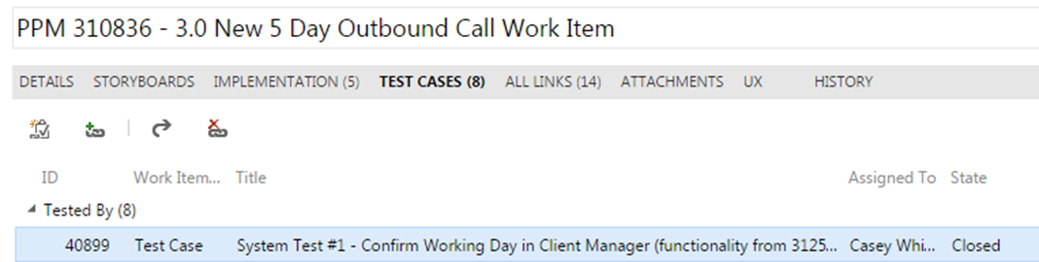
Each Test Case will have each area filled out, such as Description, Setup (when applicable), Inputs (when applicable), Steps, Expected Results and Actual Results
Each Test Case will have screen shots stored in a word document and attached to the individual test case. Screen shots are not to be in one document as a whole unless there is only one test case. Screen shots also should not be entered at the user story work item. Again, screen shots are be entered at the test case work item.
Example Test Result Document:
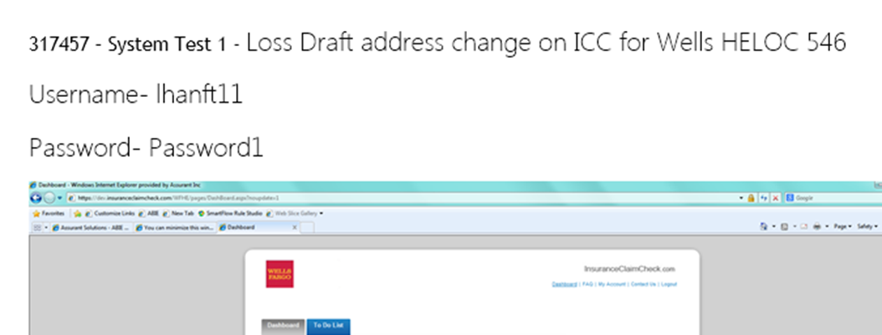
The Steps within the testing task are to be detailed so that the developer, BA, RA and Product Owner can all recreate with ease. Testing task steps are to be numbered. (Remember, we want to be able to move these to automation.) See example below.
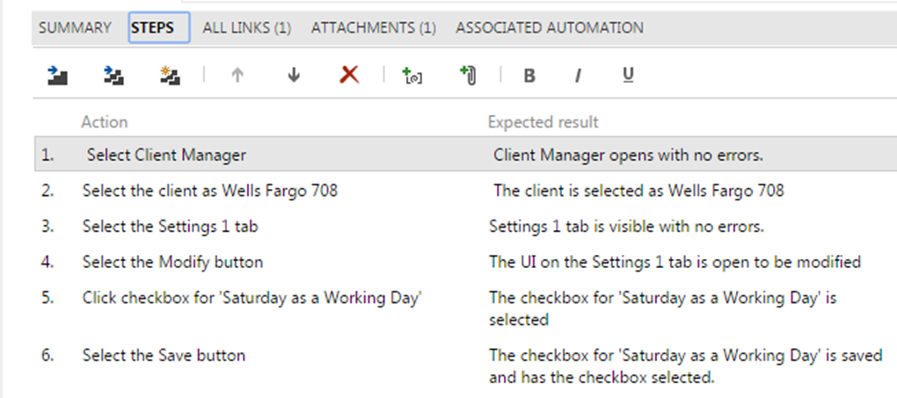
The Status field of the Test Case Work Item should be used to indicate the results of the latest execution of the Test Case:
- Ready – Test Case has not been executed
- Failed – Last execution of test case failed
- Passed – Last execution of test case passed
User Stories can have a testing task named Test Case Review. This will be an optional meeting with BA, RA and Developer to ensure the testing tasks meet the Acceptance Criteria. Moving this Testing Task to PASSED will be the indication that the Test Cases have been reviewed and concensus reached that they comprehensively cover the Acceptance Criteria.
The Automation Status field of the Test Case Work Item should be used to indicate the following:
- Blank – means this test case is not a candidate for automation
- Automated – successfully added to the automation suite
- Planned – QA Lead/Tester has determined this is a candidate for automation; (currently shown as Not Automated below but JJ requested to be changed)

Appendix C: Detailed Process and Role Flowchart:
The following chart shows a detailed view of the processes and roles described on pages 4, 5, and 6.


